Topalian
JavaScript
Text
Investigator
by
Christopher Andrew Topalian

All Rights Reserved
Copyright 2000-2024
Dedicated
to
God the Father

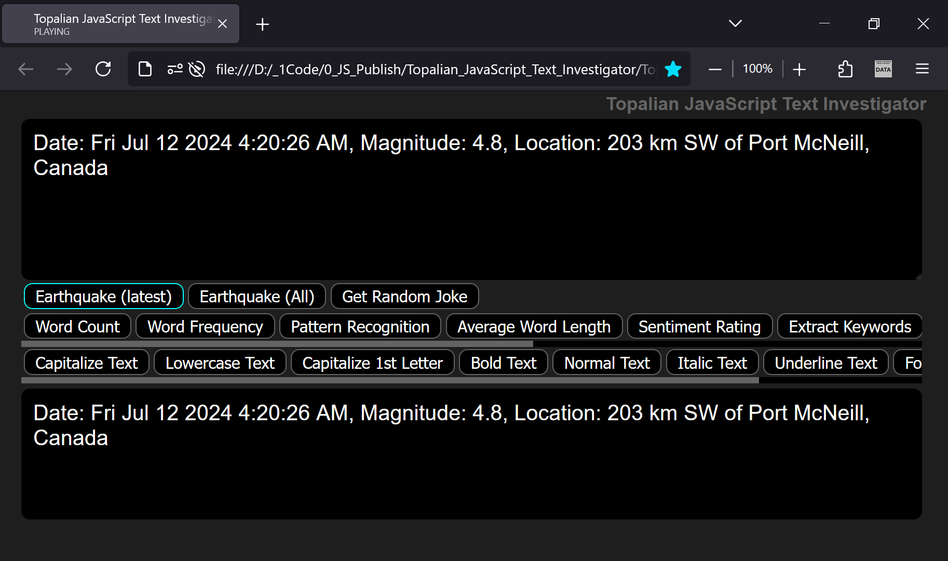
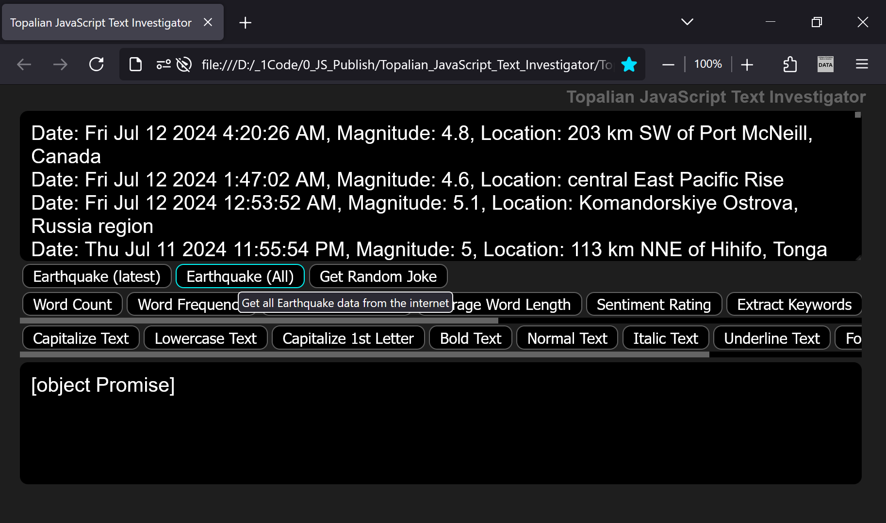
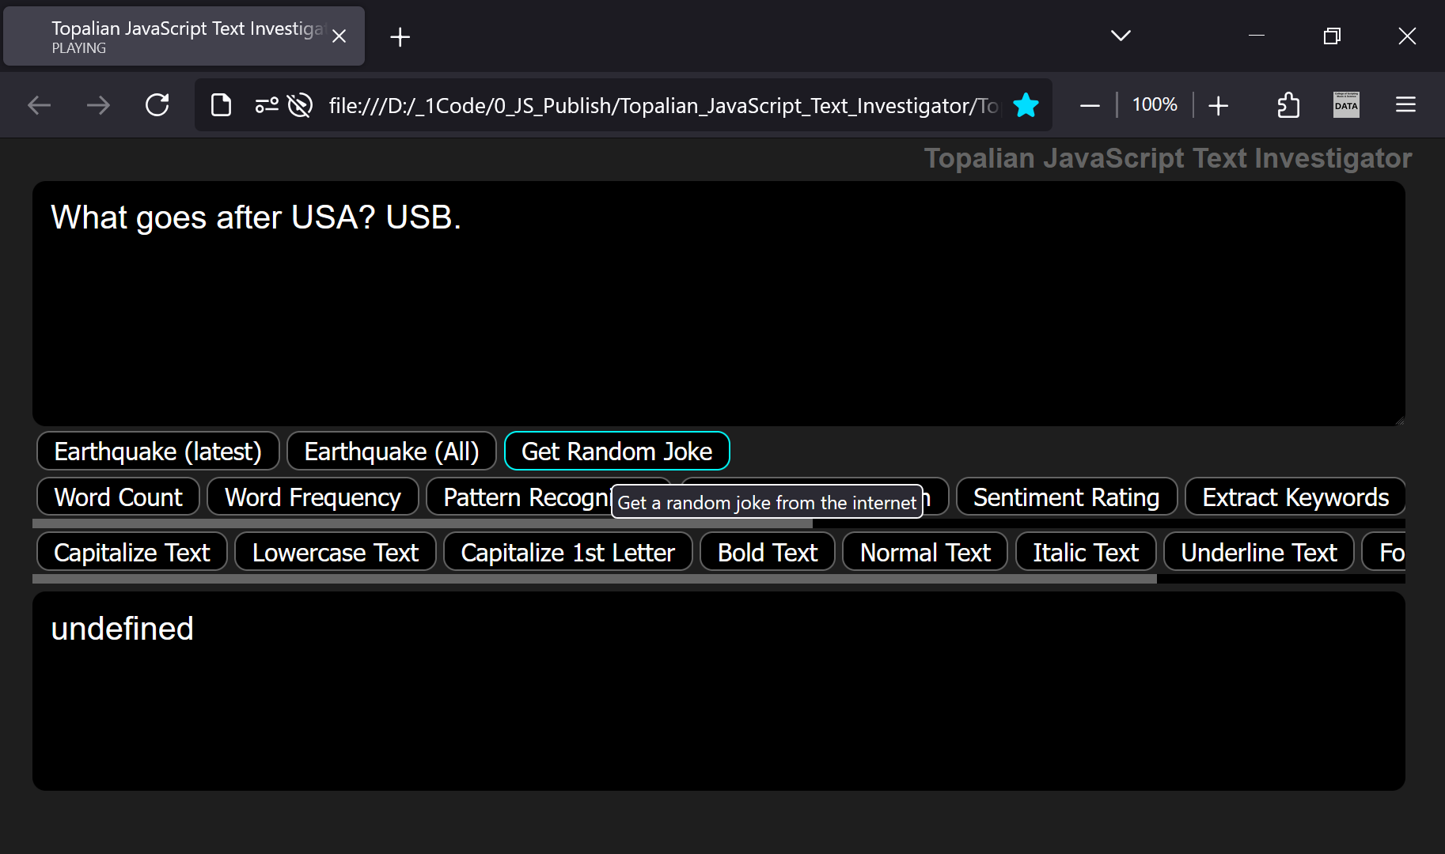
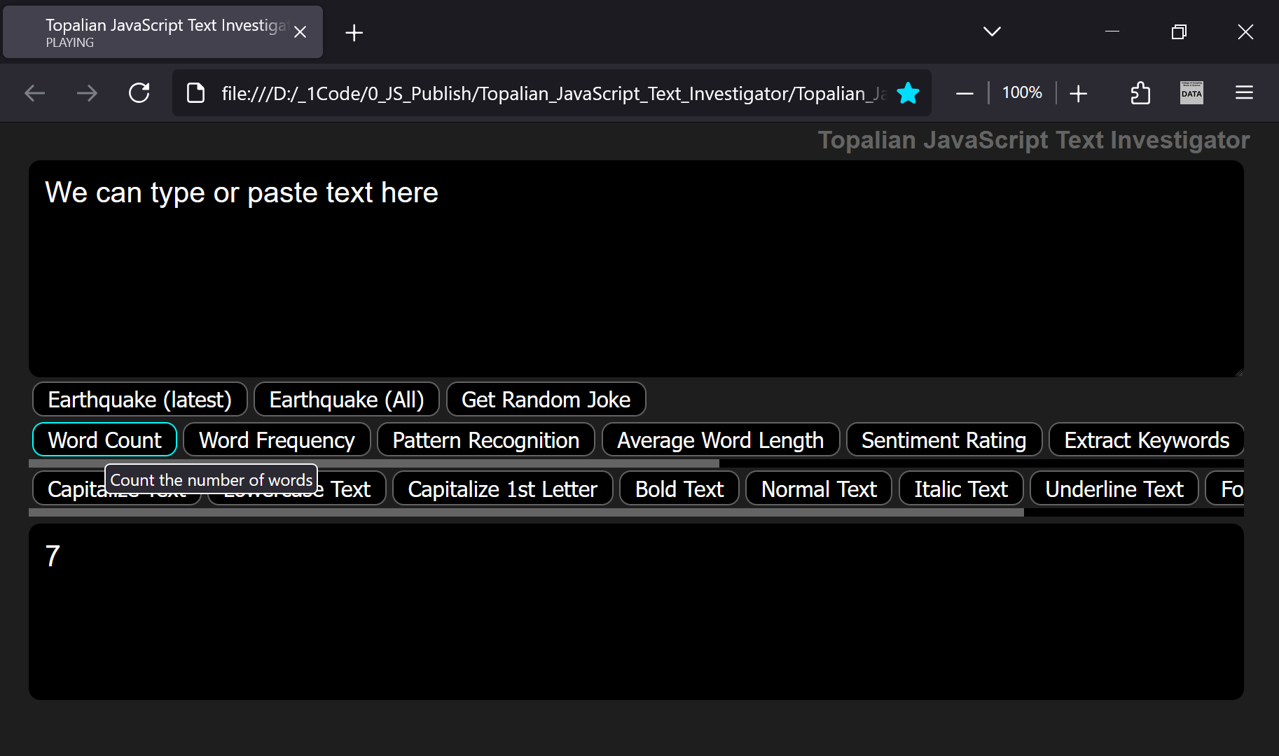

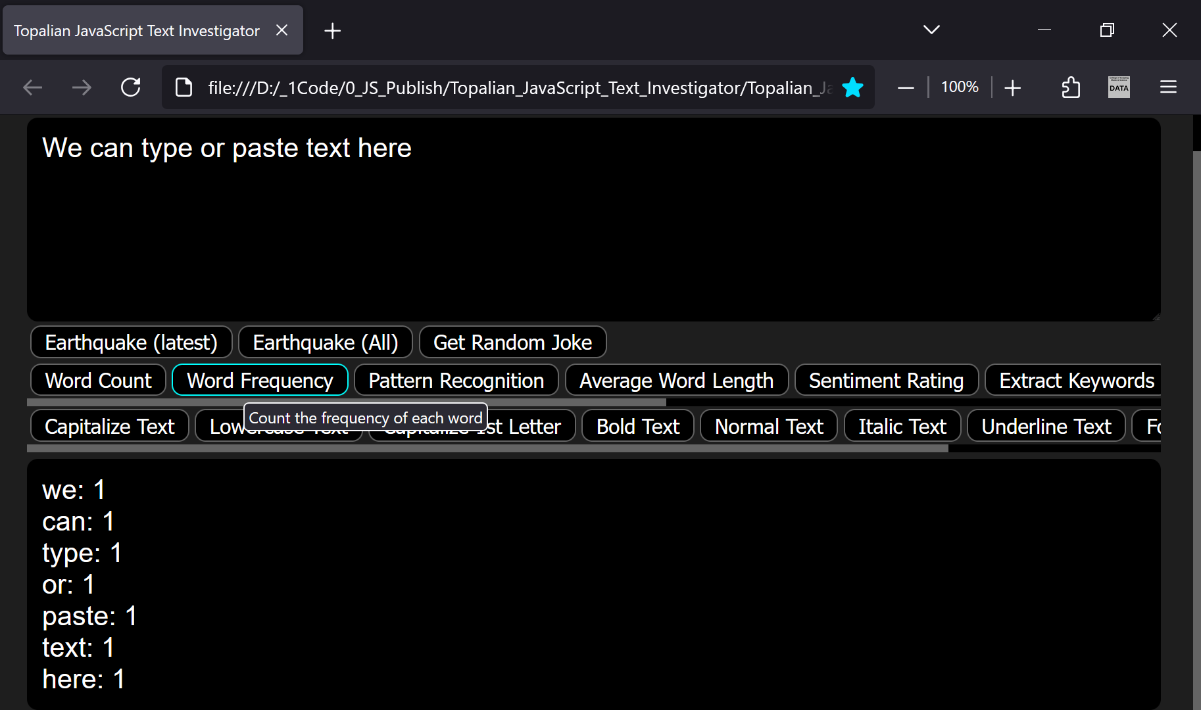
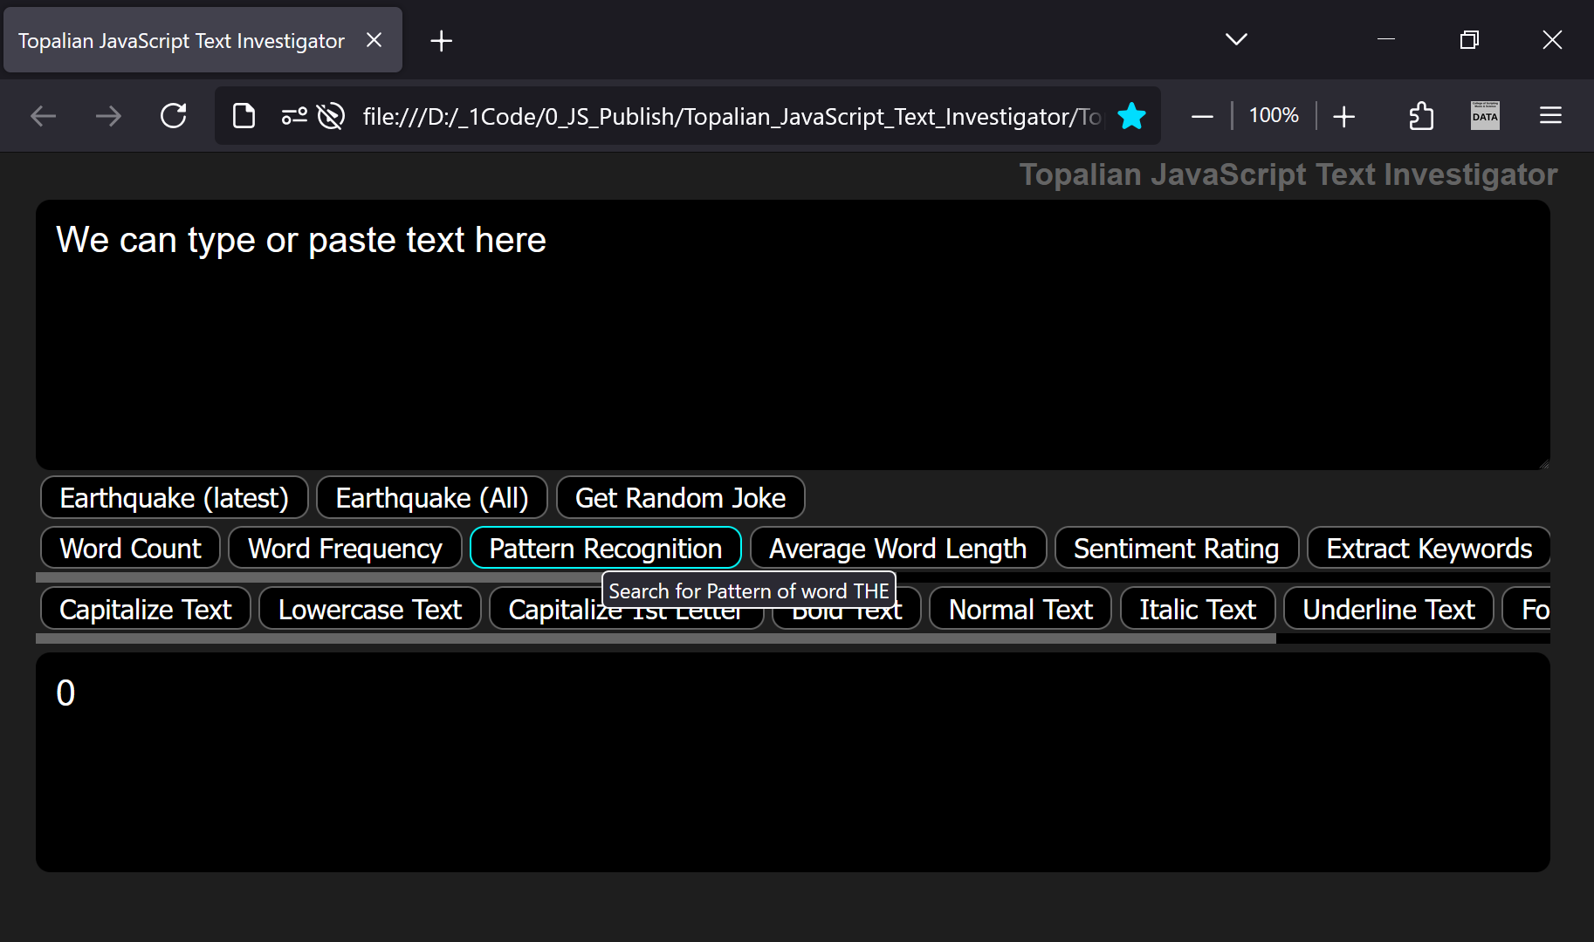

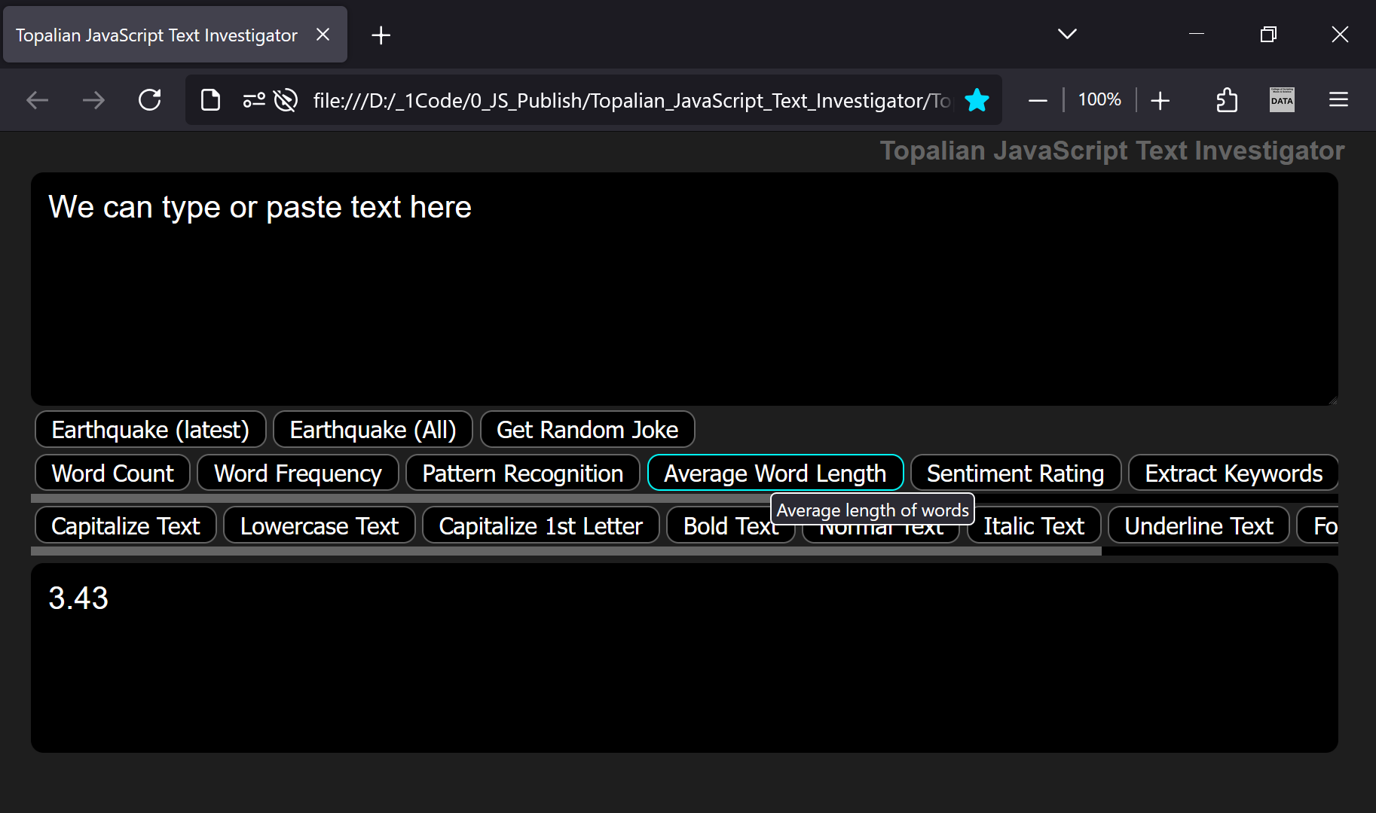

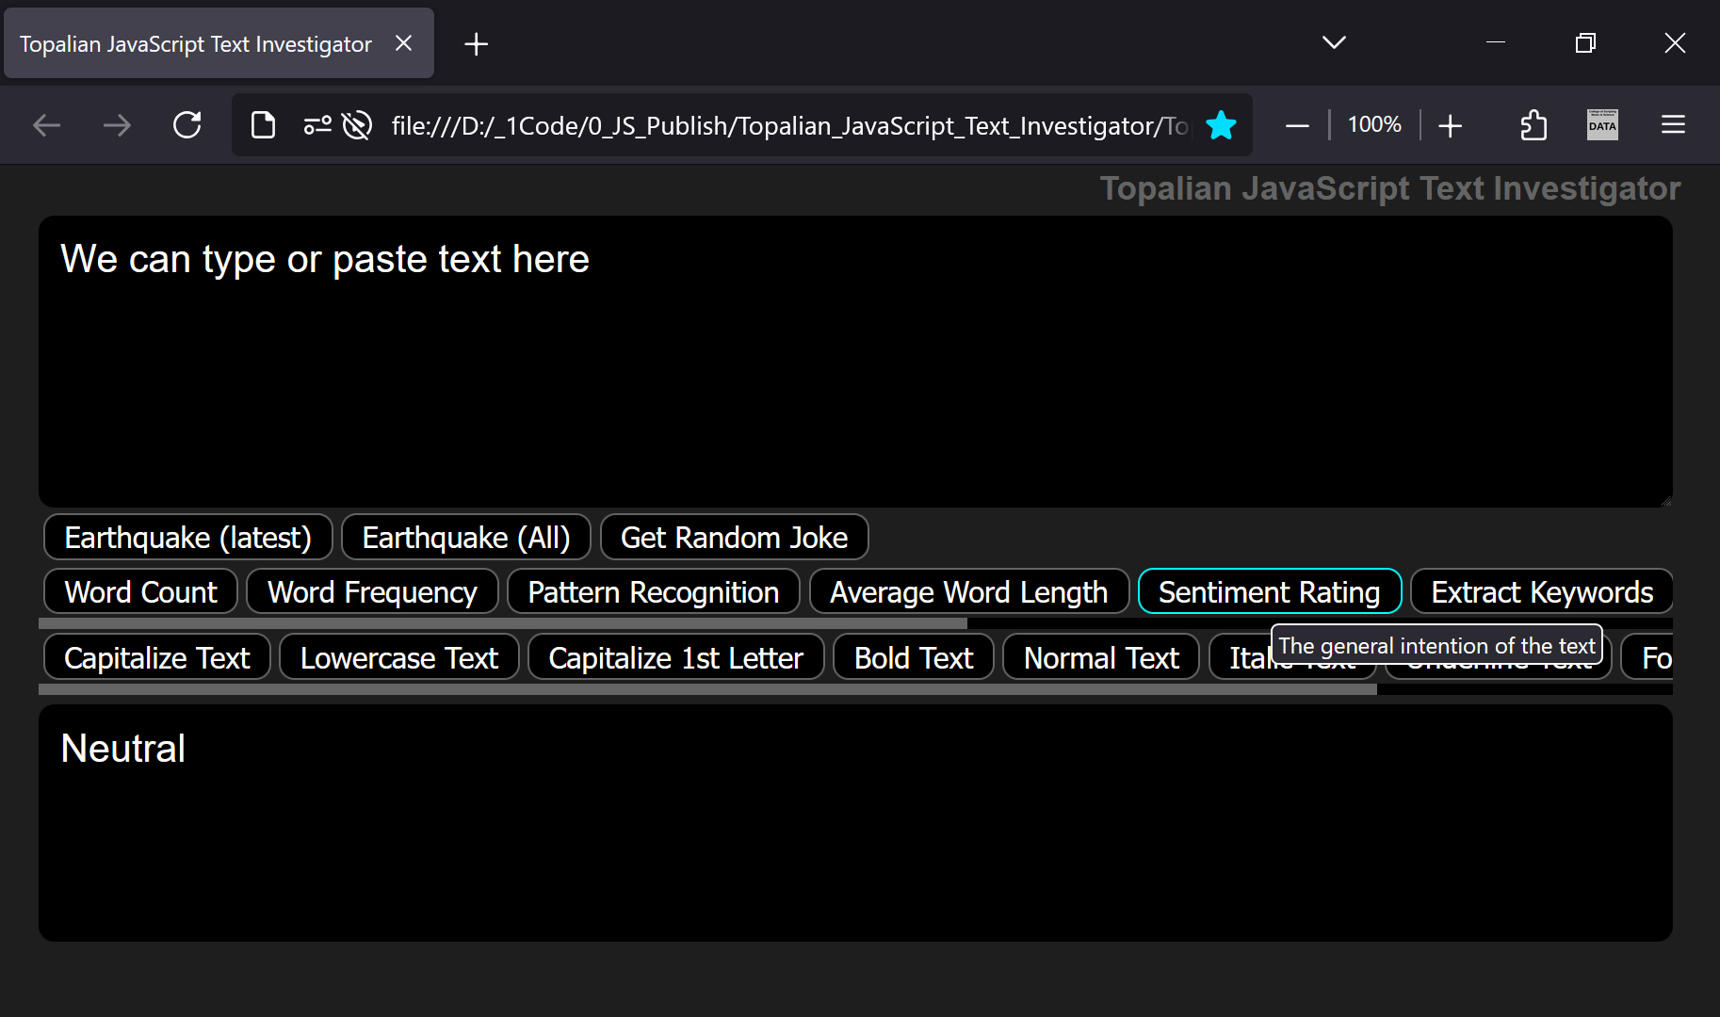

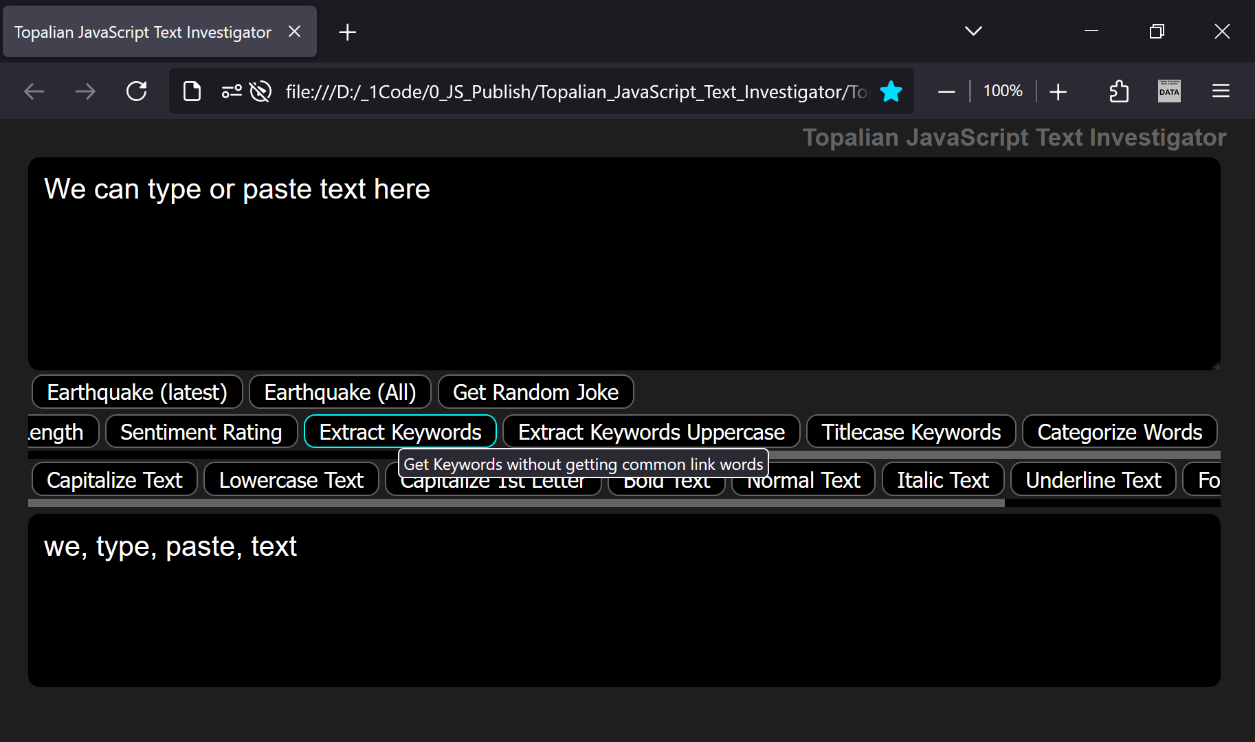

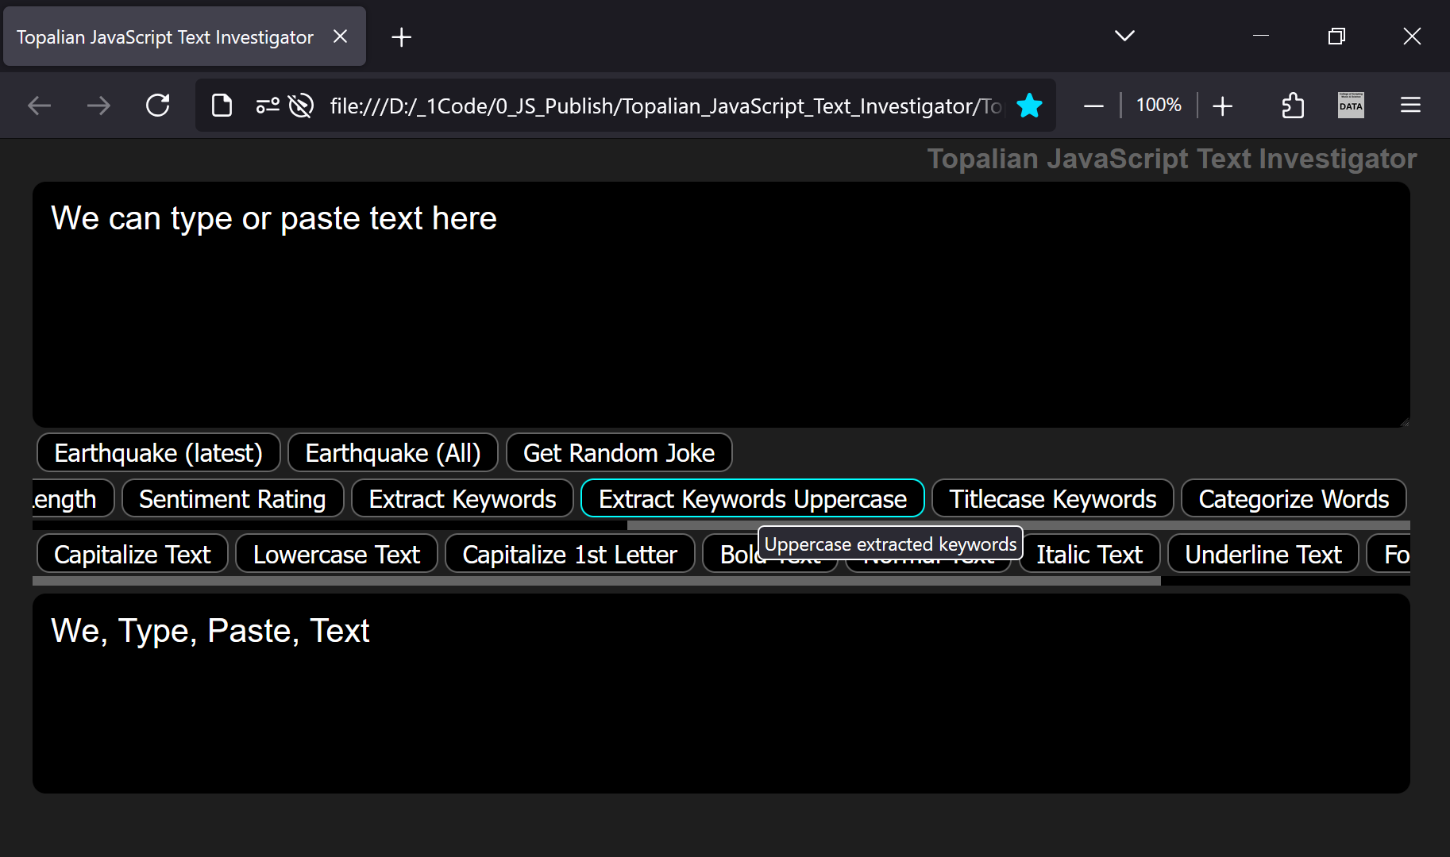

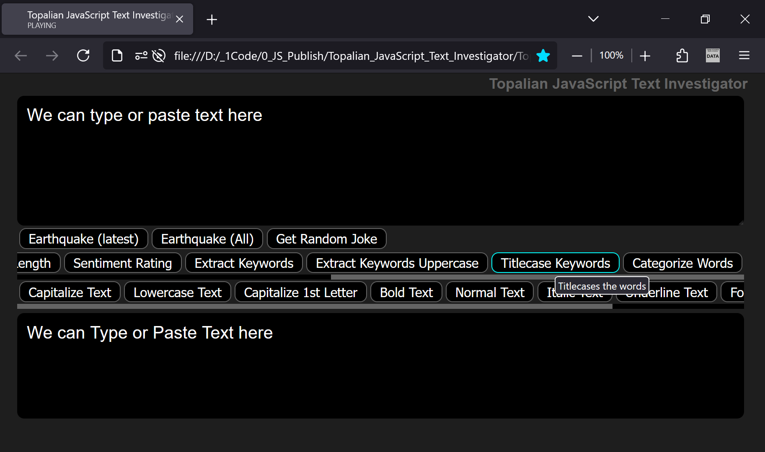

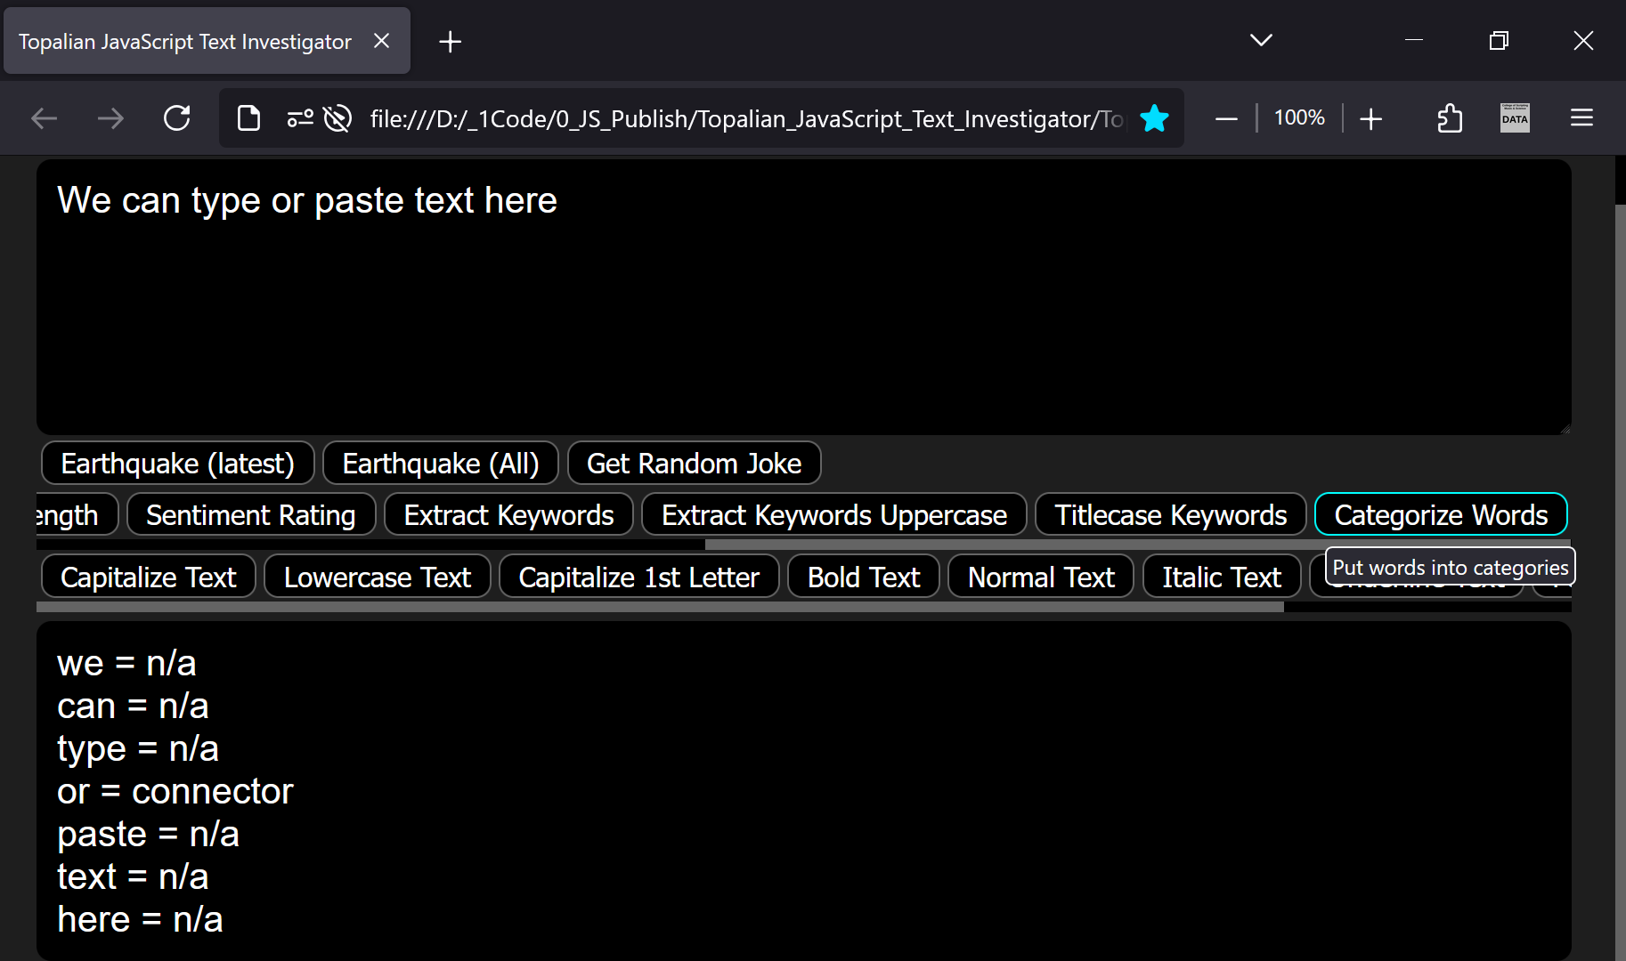

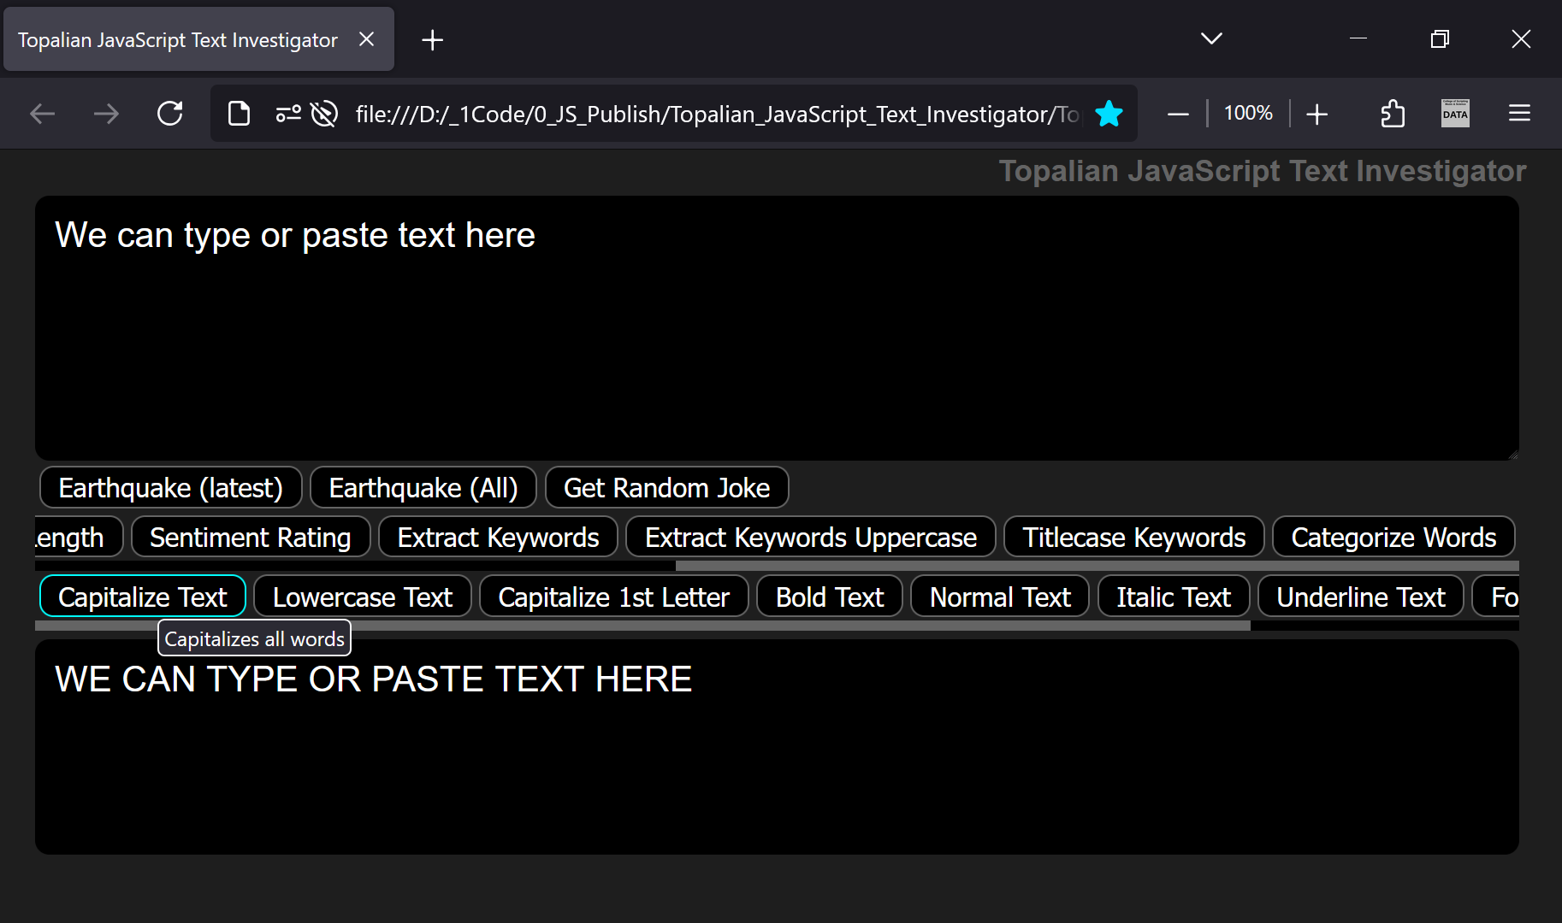

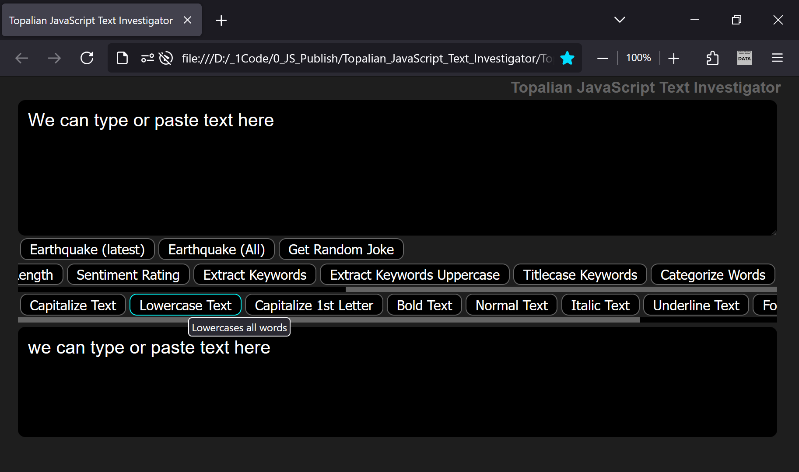

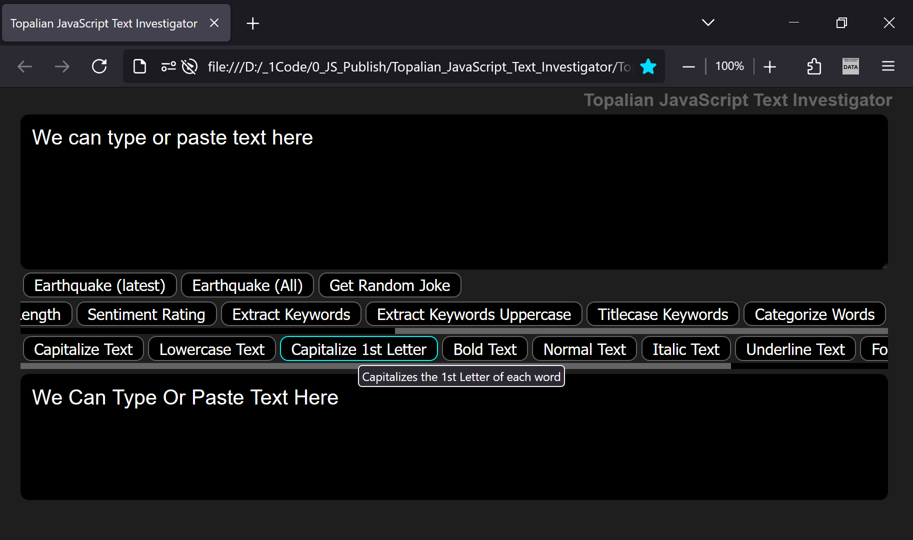

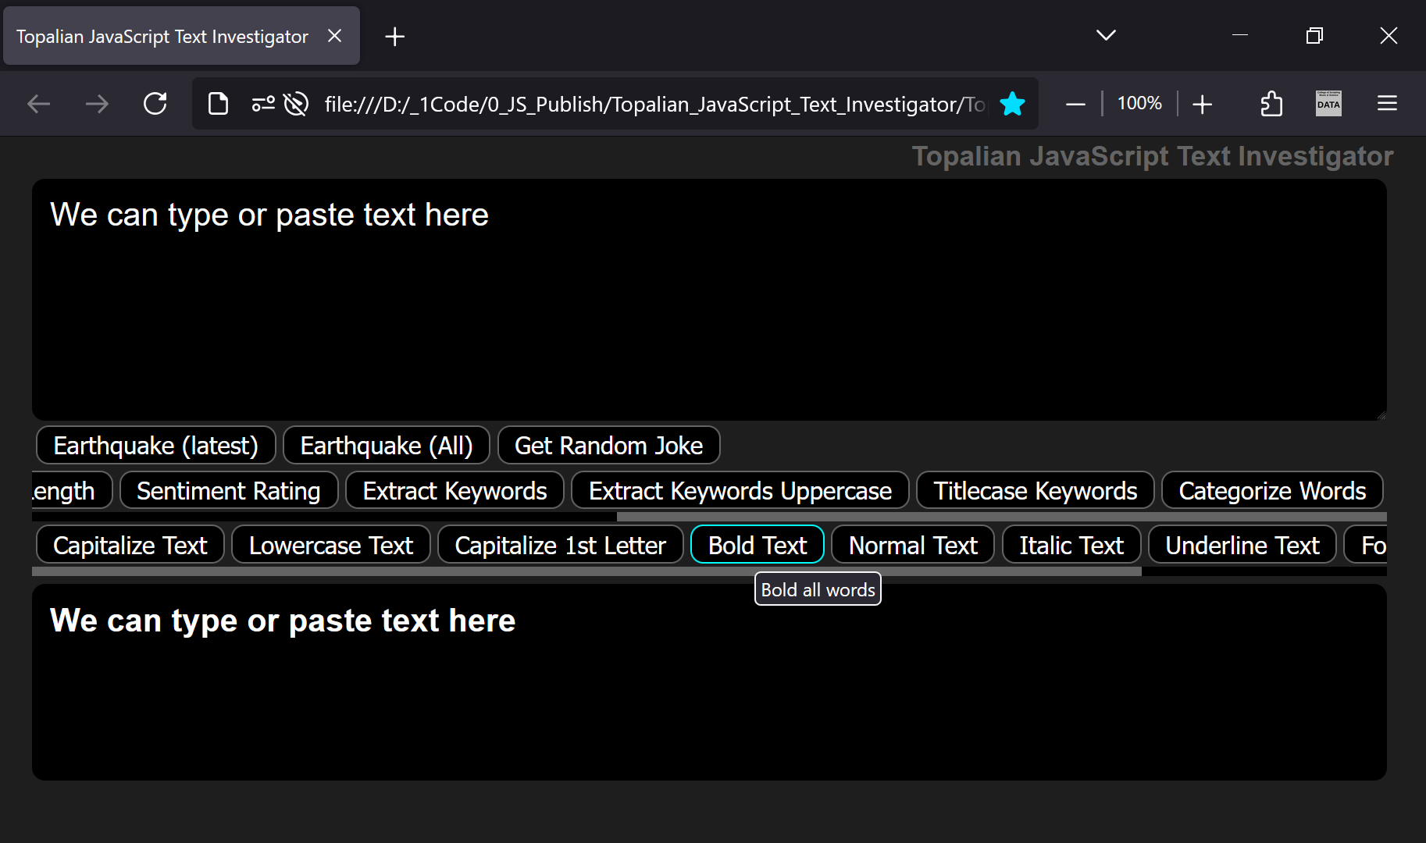

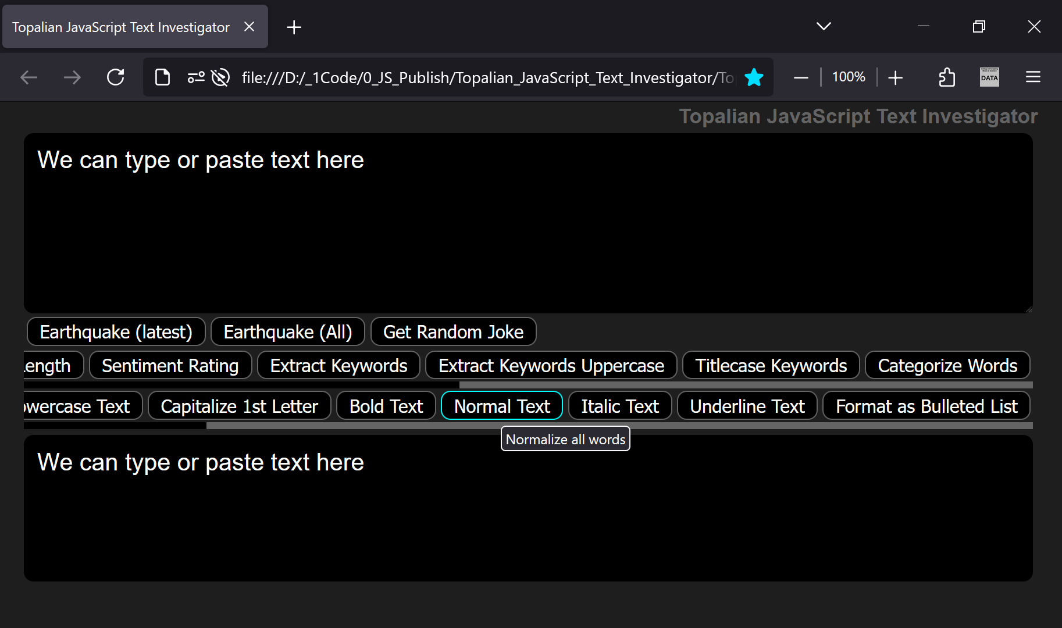
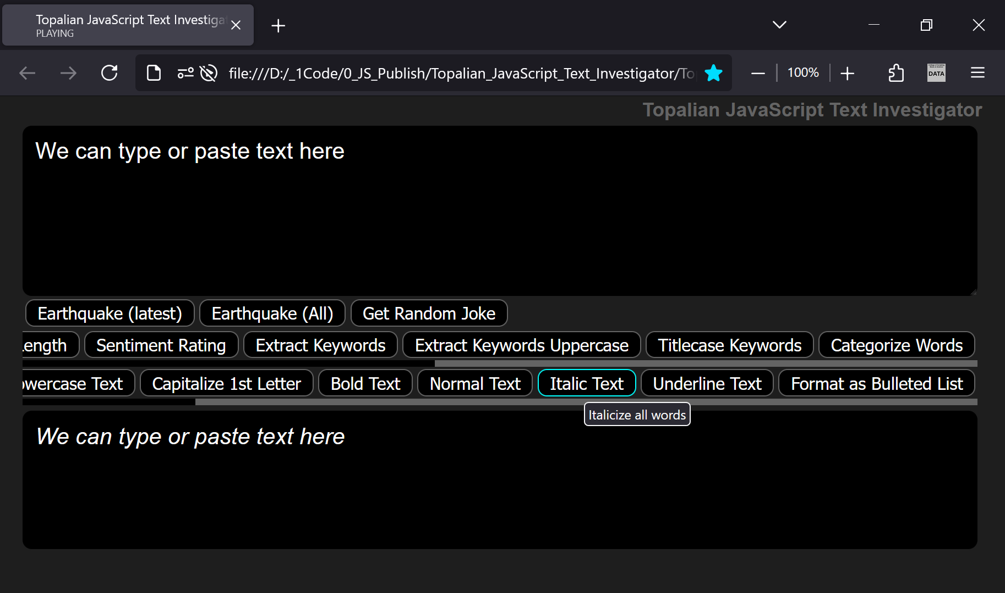

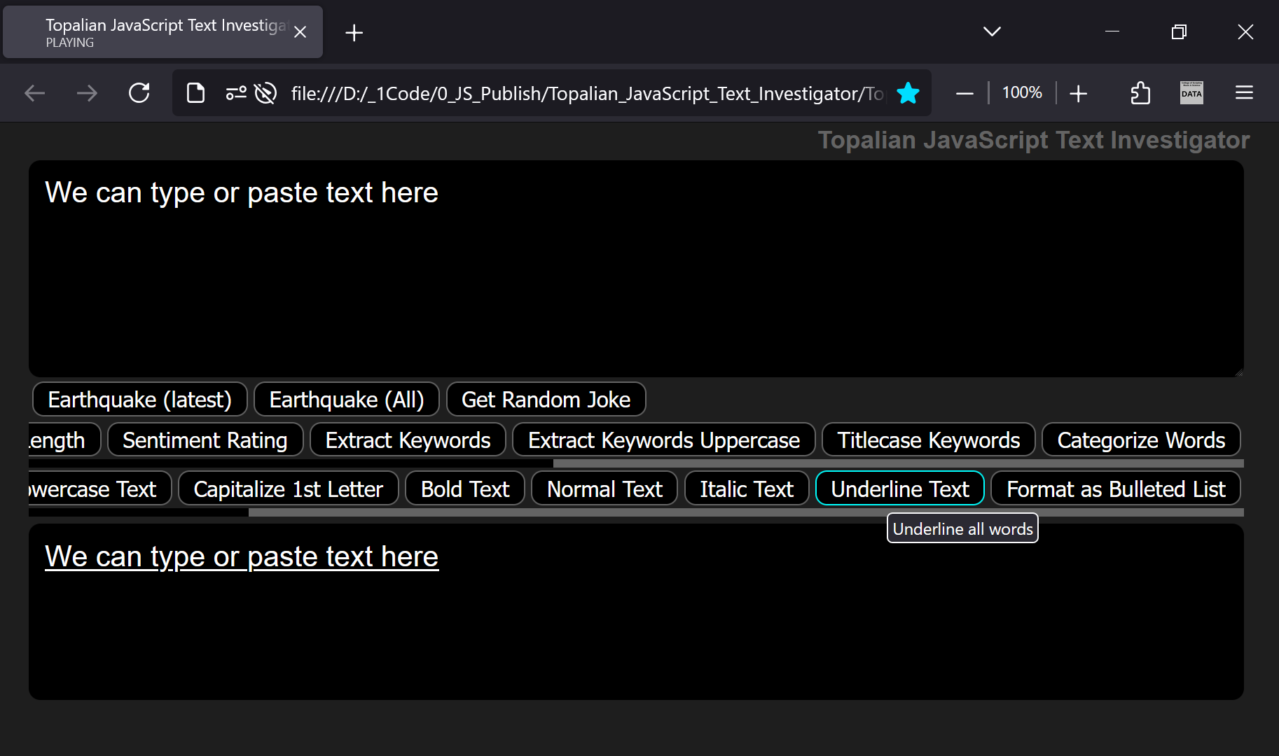

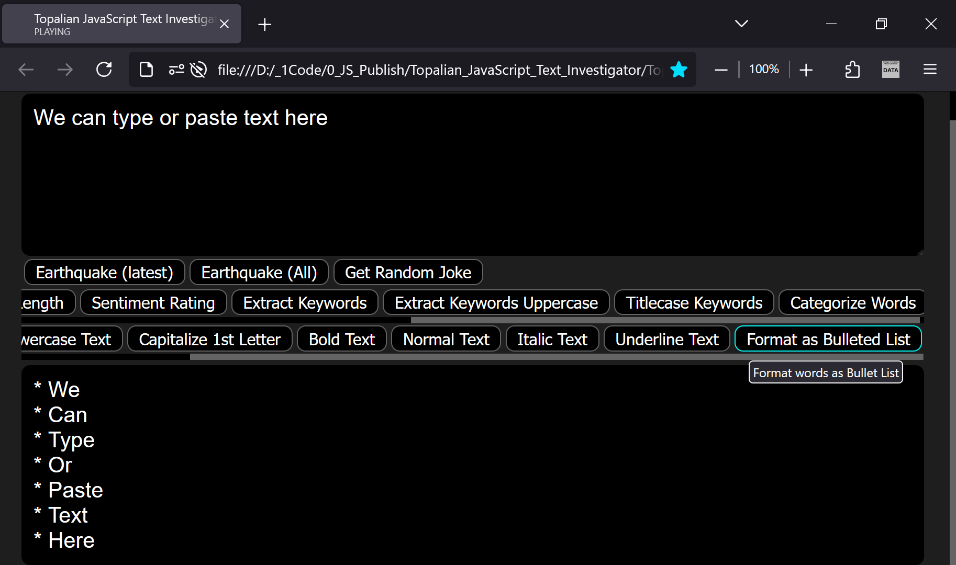

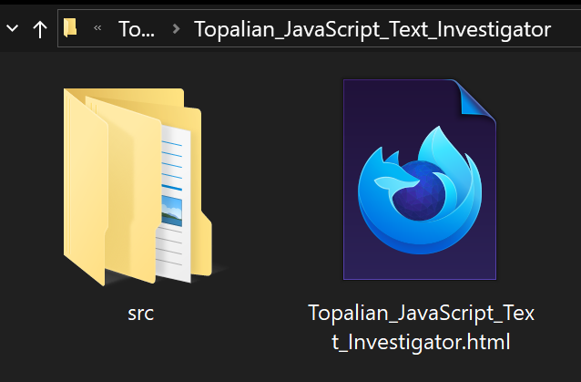
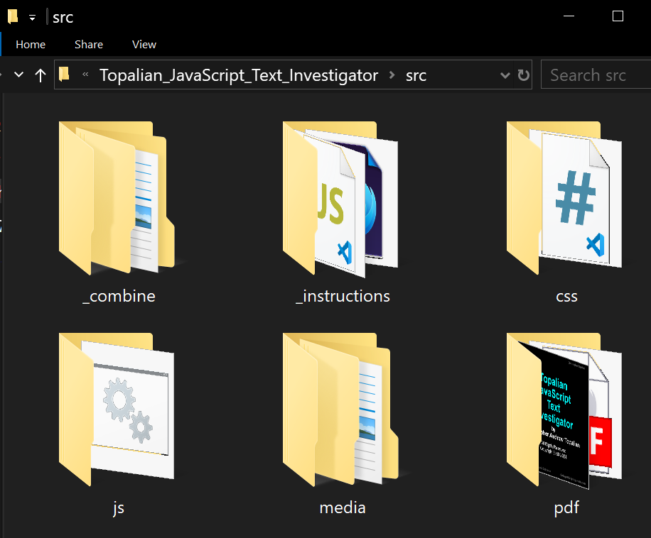
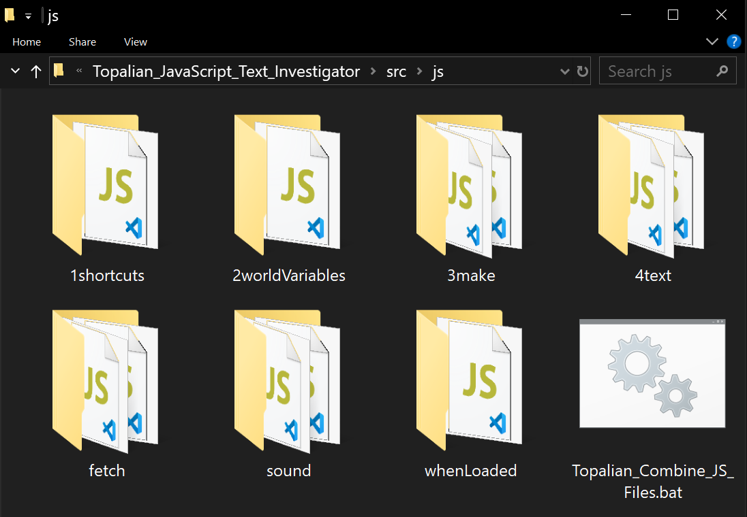

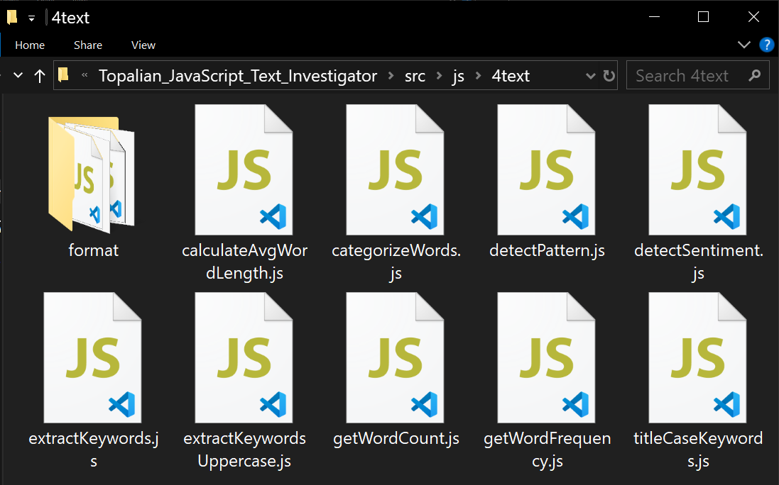

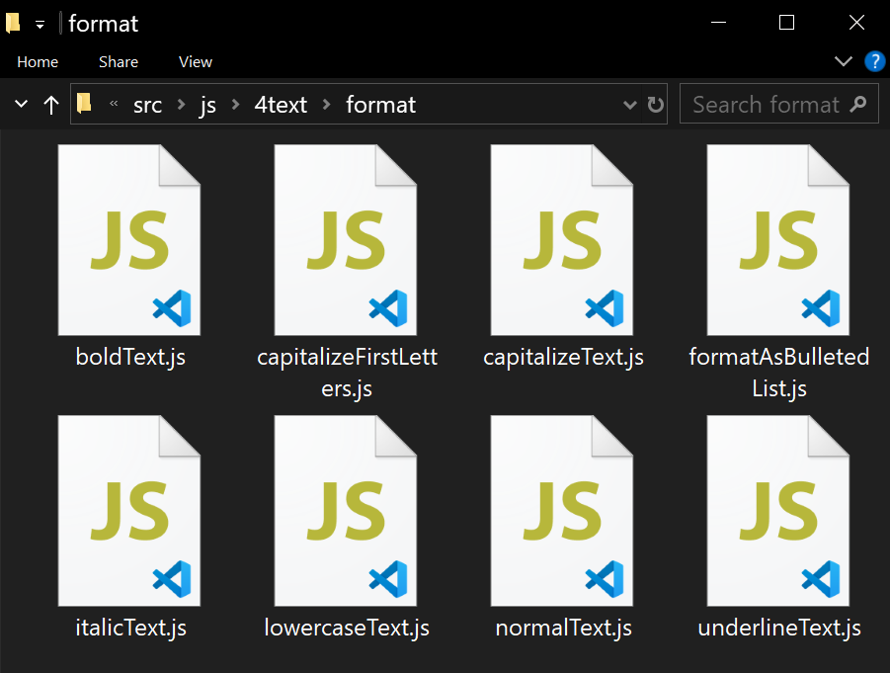

<!-- Dedicated to God the Father -->
<!-- All Rights Reserved Christopher Andrew Topalian Copyright 2000-2024 -->
<!-- https://github.com/ChristopherTopalian -->
<!-- https://github.com/ChristopherAndrewTopalian -->
<!-- https://github.com/ChristopherTopalian/ -->
<!-- Topalian_JavaScript_Text_Investigator.html -->
<!-- Version 001 - (2024-07-12) -->

<html>
<head>
<title> Topalian JavaScript Text Investigator </title>

<link rel = 'stylesheet' href = 'src/css/style001.css'>

<!-- shortcuts -->
<script src = 'src/js/1shortcuts/shortcuts.js'></script>

<!-- world variables -->
<script src = 'src/js/2worldVariables/worldVariables.js'></script>

<!-- make -->
<script src = 'src/js/3make/makeInterface.js'></script>

<script src = 'src/js/3make/makeTitleOfApp.js'></script>

<!-- text -->
<script src = 'src/js/4text/detectPattern.js'></script>

<script src = 'src/js/4text/getWordCount.js'></script>

<script src = 'src/js/4text/calculateAvgWordLength.js'></script>

<script src = 'src/js/4text/getWordFrequency.js'></script>

<script src = 'src/js/4text/detectSentiment.js'></script>

<script src = 'src/js/4text/extractKeywords.js'></script>

<script src = 'src/js/4text/categorizeWords.js'></script>

<script src = 'src/js/4text/extractKeywordsUppercase.js'></script>

<script src = 'src/js/4text/titleCaseKeywords.js'></script>

<!-- text format -->
<script src = 'src/js/4text/format/capitalizeText.js'></script>

<script src = 'src/js/4text/format/lowercaseText.js'></script>

<script src = 'src/js/4text/format/capitalizeFirstLetters.js'></script>

<script src = 'src/js/4text/format/boldText.js'></script>

<script src = 'src/js/4text/format/normalText.js'></script>

<script src = 'src/js/4text/format/italicText.js'></script>

<script src = 'src/js/4text/format/underlineText.js'></script>

<script src = 'src/js/4text/format/formatAsBulletedList.js'></script>

<!-- fetch -->
<script src = 'src/js/fetch/fetchRandomJoke.js'></script>

<script src = 'src/js/fetch/fetchMostRecentEarthquakeData.js'></script>

<script src = 'src/js/fetch/fetchAllEarthquakeData.js'></script>

<!-- sound -->
<script src = 'src/js/sound/sounds.js'></script>

<script src = 'src/js/sound/loadSounds.js'></script>

<script src = 'src/js/sound/audioPlay.js'></script>

<!-- when loaded -->
<script src = 'src/js/whenLoaded/whenLoaded.js'></script>

</head>

<body onload = 'whenLoaded();'>

</body>

</html>

/* Dedicated to God the Father */
/* All Rights Reserved Christopher Andrew Topalian Copyright 2000-2024 */
/* https://github.com/ChristopherTopalian */
/* https://github.com/ChristopherAndrewTopalian */
/* style001.css */

body
{
background-color: rgb(30, 30, 30);
font-family: Arial;
font-size: 20px;
color: rgb(255, 255, 255);
}

textarea
{
padding-left: 10px;
padding-right: 10px;
padding-top: 10px;
padding-bottom: 10px;
border: solid 1px rgb(0, 0, 0);
border-radius: 8px;
background-color: rgb(0, 0, 0);
font-family: Arial;
font-size: 20px;
color: rgb(255, 255, 255);
}

a
{
color: rgb(100, 100, 100);
text-decoration: none;
}

a:hover
{
text-decoration: underline;
}

#mainContainer
{
width: 95%;
margin: auto;
}

#textInput
{
width: 100%;
height: 150px;
}

#resultContainer
{
margin-top: 5px;
padding-left: 10px;
padding-right: 10px;
padding-top: 10px;
padding-bottom: 10px;
border: solid 1px rgb(0, 0, 0);
border-radius: 8px;
background-color: rgb(0, 0, 0);
font-family: Arial;
font-size: 20px;
color: rgb(255, 255, 255);
}

.buttonStyle001
{
max-height: 40px;
margin: 2px;
padding-left: 10px;
padding-right: 10px;
padding-top: 2px;
padding-bottom: 2px;
border: solid 1px rgb(100, 100, 100);
border-radius: 8px;
background-color: rgb(0, 0, 0);
font-size: 15px;
color: rgb(255, 255, 255);
cursor: pointer;
box-sizing: border-box;
}

.buttonStyle001:hover
{
border-color: rgb(0, 255, 255);
}

.buttonStyle001:active
{
position: relative;
top: 1px;
border-color: rgb(255, 0, 255);
color: rgb(255, 0, 255);
}

* {
scrollbar-width: thin;
scrollbar-color: rgb(100, 100, 100) rgb(0, 0, 0);
}

// Dedicated to God the Father
// All Rights Reserved Christopher Andrew Topalian Copyright 2000-2024
// https://github.com/ChristopherTopalian
// https://github.com/ChristopherAndrewTopalian
// shortcuts.js

function ge(whichId)
{
let result = document.getElementById(whichId);
return result;
}

function ce(whichType)
{
let result = document.createElement(whichType);
return result;
}

function ba(whichElement)
{
let result = document.body.append(whichElement);
return result;
}

// Dedicated to God the Father
// All Rights Reserved Christopher Andrew Topalian Copyright 2000-2024
// https://github.com/ChristopherTopalian
// https://github.com/ChristopherAndrewTopalian
// worldVariables.js

let online = false;

// Dedicated to God the Father
// All Rights Reserved Christopher Andrew Topalian Copyright 2000-2024
// https://github.com/ChristopherTopalian
// https://github.com/ChristopherAndrewTopalian
// makeInterface.js

function makeInterface()
{
// mainContainer
let mainContainer = ce('div');
mainContainer.id = 'mainContainer';
mainContainer.style.position = 'absolute';
mainContainer.style.left = '20px';
mainContainer.style.top = '25px';
ba(mainContainer);

//-//

// textInput
let textInput = ce('textarea');
textInput.id = 'textInput';
textInput.placeholder = 'Enter words here...';
mainContainer.append(textInput);

//-//

// btnDivInternetData
let btnDivInternetData = ce('div');
btnDivInternetData.style.display = 'flex';
btnDivInternetData.style.flexDirection = 'row';
btnDivInternetData.style.overflowX = 'auto';
btnDivInternetData.style.whiteSpace = 'nowrap';

// horizontal scrolling mouse wheel, without needing to hold shift button
btnDivInternetData.addEventListener('wheel', function(event)
{
if (event.deltaY !== 0)
{
btnDivInternetData.scrollLeft += event.deltaY;
event.preventDefault();
}
});

mainContainer.append(btnDivInternetData);

//-//

let internetDataBtnArray =
[
{
name: 'Earthquake (latest)',
functionName: `fetchMostRecentEarthquakeData()`,
description: 'Get most recent Earthquake data from the internet'
},

{
name: 'Earthquake (All)',
functionName: `fetchAllEarthquakeData()`,
description: 'Get all Earthquake data from the internet'
},

{
name: 'Get Random Joke',
functionName: `fetchRandomJoke()`,
description: 'Get a random joke from the internet'
}
];

for (let i = 0; i < internetDataBtnArray.length; i++)
{
let theButton = ce('button');
theButton.className = 'buttonStyle001';
theButton.innerHTML = internetDataBtnArray[i].name;
theButton.title = internetDataBtnArray[i].description;
theButton.onmouseover = function()
{
audioPlay('sfx_warp_001', 1.0);
};

theButton.onclick = function(buttonInfo)
{
audioPlay('sfx_blip_001', 1.0);

ge('resultContainer').innerHTML = eval(internetDataBtnArray[i].functionName);
}

btnDivInternetData.append(theButton);
}

//-//

// btnDivAnalyzeText
let btnDivAnalyzeText = ce('div');
btnDivAnalyzeText.style.display = 'flex';
btnDivAnalyzeText.style.flexDirection = 'row';
btnDivAnalyzeText.style.overflowX = 'auto';
btnDivAnalyzeText.style.whiteSpace = 'nowrap';

// horizontal scrolling mouse wheel, without needing to hold shift button
btnDivAnalyzeText.addEventListener('wheel', function(event)
{
if (event.deltaY !== 0)
{
btnDivAnalyzeText.scrollLeft += event.deltaY;
event.preventDefault();
}
});

mainContainer.append(btnDivAnalyzeText);

//-//

let analyzeButtons =
[
{
name: 'Word Count',
functionName: `getWordCount(textInput.value)`,
description: 'Count the number of words'
},

{
name: 'Word Frequency',
functionName: `getWordFrequency(textInput.value)`,
description: 'Count the frequency of each word'
},

{
name: 'Pattern Recognition',
functionName: `detectPattern(textInput.value)`,
description: 'Search for Pattern of word THE'
},

{
name: 'Average Word Length',
functionName: `calculateAvgWordLength(textInput.value)`,
description: 'Average length of words'
},

{
name: 'Sentiment Rating',
functionName: `detectSentiment(textInput.value)`,
description: 'The general intention of the text'
},

{
name: 'Extract Keywords',
functionName: `extractKeywords(textInput.value)`,
description: 'Get Keywords without getting common link words'
},

{
name: 'Extract Keywords Uppercase',
functionName: `extractKeywordsUppercase(textInput.value)`,
description: 'Uppercase extracted keywords'
},

{
name: 'Titlecase Keywords',
functionName: `titleCaseKeywords(textInput.value)`,
description: 'Titlecases the words'
},

{
name: 'Categorize Words',
functionName: `categorizeWords(textInput.value)`,
description: 'Put words into categories'
},

];

for (let i = 0; i < analyzeButtons.length; i++)
{
let theButton = ce('button');
theButton.className = 'buttonStyle001';
theButton.innerHTML = analyzeButtons[i].name;
theButton.title = analyzeButtons[i].description;
theButton.onmouseover = function()
{
audioPlay('sfx_warp_001', 1.0);
};

theButton.onclick = function(buttonInfo)
{
audioPlay('sfx_blip_001', 1.0);

ge('resultContainer').innerHTML = eval(analyzeButtons[i].functionName);
}

btnDivAnalyzeText.append(theButton);
}

//-//

// btnDivFormatting
let btnDivFormatting = ce('div');
btnDivFormatting.style.display = 'flex';
btnDivFormatting.style.flexDirection = 'row';
btnDivFormatting.style.overflowX = 'auto';
btnDivFormatting.style.whiteSpace = 'nowrap';

// horizontal scrolling mouse wheel, without needing to hold shift button
btnDivFormatting.addEventListener('wheel', function(event)
{
if (event.deltaY !== 0)
{
btnDivFormatting.scrollLeft += event.deltaY;
event.preventDefault();
}
});
mainContainer.append(btnDivFormatting);

//-//

let formattingButtons =
[
{
name: 'Capitalize Text',
functionName: `capitalizeText(textInput.value)`,
description: 'Capitalizes all words'
},

{
name: 'Lowercase Text',
functionName: `lowercaseText(textInput.value)`,
description: 'Lowercases all words'
},

{
name: 'Capitalize 1st Letter',
functionName: `capitalizeFirstLetters(textInput.value)`,
description: 'Capitalizes the 1st Letter of each word'
},

{
name: 'Bold Text',
functionName: `boldText(textInput.value)`,
description: 'Bold all words'
},

{
name: 'Normal Text',
functionName: `normalText(textInput.value)`,
description: 'Normalize all words'
},

{
name: 'Italic Text',
functionName: `italicText(textInput.value)`,
description: 'Italicize all words'
},

{
name: 'Underline Text',
functionName: `underlineText(textInput.value)`,
description: 'Underline all words'
},

{
name: 'Format as Bulleted List',
functionName: `formatAsBulletedList(textInput.value)`,
description: 'Format words as Bullet List'
}
];

for (let i = 0; i < formattingButtons.length; i++)
{
let theButton = ce('button');
theButton.className = 'buttonStyle001';
theButton.innerHTML = formattingButtons[i].name;
theButton.title = formattingButtons[i].description;
theButton.onmouseover = function()
{
audioPlay('sfx_warp_001', 1.0);
};

theButton.onclick = function(buttonInfo)
{
audioPlay('sfx_blip_001', 1.0);

ge('resultContainer').innerHTML = eval(formattingButtons[i].functionName);
}

btnDivFormatting.append(theButton);
}

//-//

let resultContainer = ce('div');
resultContainer.id = 'resultContainer';
resultContainer.style.minHeight = '100px';
mainContainer.append(resultContainer);
}

// Dedicated to God the Father
// All Rights Reserved Christopher Andrew Topalian Copyright 2000-2024
// https://github.com/ChristopherTopalian
// https://github.com/ChristopherAndrewTopalian
// makeTitleOfApp.js

function makeTitleOfApp()
{
// titleContainer
let titleContainer = ce('div');
titleContainer.style.position = 'absolute';
titleContainer.style.right = '20px';
titleContainer.style.top = titleContainer.style.top = '2px';
titleContainer.style.zIndex = 1;
ba(titleContainer);

//-//

// titleOfApp
let titleOfApp = ce('div');
titleOfApp.id = 'titleOfApp';
titleOfApp.innerHTML =
`<a href = 'https://github.com/christophertopalian/topalian_javascript_text_investigator' target = '_blank'> Topalian JavaScript Text Investigator </a>`;
titleOfApp.style.fontSize = '17px';
titleOfApp.style.fontWeight = 'bold';
titleContainer.append(titleOfApp);
}

// Dedicated to God the Father
// All Rights Reserved Christopher Andrew Topalian Copyright 2000-2024
// https://github.com/ChristopherTopalian
// https://github.com/ChristopherAndrewTopalian
// calculateAvgWordLength.js

function calculateAvgWordLength(whichText)
{
let words = whichText.split(/\s+/);
let totalLength = 0;
let wordCount = 0;

for (let i = 0; i < words.length; i++)
{
let word = words[i];

if (word.length > 0)
{
totalLength += word.length;
wordCount++;
}
}

if (wordCount > 0)
{
return (totalLength / wordCount).toFixed(2);
}
else
{
return 0;
}
}
// Dedicated to God the Father
// All Rights Reserved Christopher Andrew Topalian Copyright 2000-2024
// https://github.com/ChristopherTopalian
// https://github.com/ChristopherAndrewTopalian
//categorizeWords.js

function categorizeWords(whichText)
{
// define word categories
let categories =
{
specifier: ["the", "a", "an", "those", "that", "them", "they", "this"],
connector: ["and", "but", "or", "however", "therefore"],
thing: ["chair", "table", "car"],
time: ["early", "late", "morning", "evening", "yesterday", "today", "tomorrow", "now", "then", "when"]
};

// convert whichText to lowercase and split it into words
let words = whichText.toLowerCase().split(' ');

// array to hold categorized words
let categorizedWords = [];

// loop through words in whichText
for (let i = 0; i < words.length; i++)
{
let word = words[i];
let categoryFound = false;

// check each category
let categoryKeys = Object.keys(categories);

for (let k = 0; k < categoryKeys.length; k++)
{
let category = categoryKeys[k];

let categoryWords = categories[category];

for (let j = 0; j < categoryWords.length; j++)
{
if (word === categoryWords[j])
{
categorizedWords.push(word + " = " + category);

categoryFound = true;
break;
}
}

if (categoryFound)
{
break;
}
}

// if no category found, label as n/a
if (!categoryFound)
{
categorizedWords.push(word + " = n/a");
}
}

return categorizedWords.join("<br> ");
}

// Dedicated to God the Father
// All Rights Reserved Christopher Andrew Topalian Copyright 2000-2024
// https://github.com/ChristopherTopalian
// https://github.com/ChristopherAndrewTopalian
// detectPattern.js

function detectPattern(whichText)
{
let pattern = /the/gi;

let matches = whichText.match(pattern);

let matchCount;

if (matches)
{
matchCount = matches.length;
}
else
{
matchCount = 0;
}

return matchCount;
}

// Dedicated to God the Father
// All Rights Reserved Christopher Andrew Topalian Copyright 2000-2024
// https://github.com/ChristopherTopalian
// https://github.com/ChristopherAndrewTopalian
// detectSentiment.js

function detectSentiment(whichText)
{
// positive words
let positiveWords = ["happy", "joy", "love", "excellent", "good", "great", "fantastic", "positive", "nice", "wonderful"];

// negative words
let negativeWords = ["sad", "anger", "hate", "terrible", "bad", "horrible", "negative", "mean", "evil"];

// initialize sentiment scores
let positiveScore = 0;
let negativeScore = 0;

// convert whichText to lowercase and split it into words
let words = whichText.toLowerCase().split(/\W+/);

// loop through words in whichText
for (let i = 0; i < words.length; i++)
{
let word = words[i];

// is word in list of pos words
for (let j = 0; j < positiveWords.length; j++)
{
if (word === positiveWords[j])
{
positiveScore++;
// exit inner loop if match found
break;
}
}

// is word in list of neg words
for (let k = 0; k < negativeWords.length; k++)
{
if (word === negativeWords[k])
{
negativeScore++;
// exit inner loop if match found
break;
}
}
}

let sentiment;

// determine sentiment
if (positiveScore > negativeScore)
{
sentiment = "Positive";
}
else if (negativeScore > positiveScore)
{
sentiment = "Negative";
}
else
{
sentiment = "Neutral";
}

return sentiment;
}

// Dedicated to God the Father
// All Rights Reserved Christopher Andrew Topalian Copyright 2000-2024
// https://github.com/ChristopherTopalian
// https://github.com/ChristopherAndrewTopalian
// extractKeywords.js

function extractKeywords(whichText)
{
// array of common stop words to ignore
let stopWords = ["a", "an", "and", "the", "in", "on", "at", "of", "to", "is", "it", "that", "this", "with", "for", "as", "by", "but", "or", "nor", "up", "down", "out", "over", "under", "again", "further", "then", "once", "here", "there", "when", "where", "why", "how", "all", "any", "both", "each", "few", "more", "most", "other", "some", "such", "no", "nor", "too", "very", "can", "will", "just", "should", "now"];

// convert whichText to lowercase and split it into words
let words = whichText.toLowerCase().split(' ');

// object to store word frequencies
let wordFrequencies = {};

// loop through words in whichText
for (let i = 0; i < words.length; i++)
{
let word = words[i];

let isStopWord = false;

// is word not a stop word
for (let j = 0; j < stopWords.length; j++)
{
if (word === stopWords[j])
{
isStopWord = true;
break;
}
}

if (!isStopWord && word.length > 1)
{
// if word is not a stop word, count its frequency
if (wordFrequencies[word])
{
wordFrequencies[word]++;
}
else
{
wordFrequencies[word] = 1;
}
}
}

// convert word frequencies object into an array of [word, frequency] pairs
let frequencyArray = [];

for (let word in wordFrequencies)
{
frequencyArray.push([word, wordFrequencies[word]]);
}

// sort array by frequency in descending order
frequencyArray.sort(function(a, b)
{
return b[1] - a[1];
});

// get top 10 keywords
let topKeywords = frequencyArray.slice(0, 10).map(function(pair)
{
return pair[0];
});

// return top keywords as comma separated string
return topKeywords.join(', ');
}
// Dedicated to God the Father
// All Rights Reserved Christopher Andrew Topalian Copyright 2000-2024
// https://github.com/ChristopherTopalian
// https://github.com/ChristopherAndrewTopalian
// extractKeywordsUppercase.js

function extractKeywordsUppercase(whichText)
{
// array of common stop words to ignore
let stopWords = ["a", "an", "and", "the", "in", "on", "at", "of", "to", "is", "it", "that", "this", "with", "for", "as", "by", "but", "or", "nor", "up", "down", "out", "over", "under", "again", "further", "then", "once", "here", "there", "when", "where", "why", "how", "all", "any", "both", "each", "few", "more", "most", "other", "some", "such", "no", "nor", "too", "very", "can", "will", "just", "should", "now"];

// convert whichText to lowercase and split it into words
let words = whichText.toLowerCase().split(' ');

// object to store word frequencies
let wordFrequencies = {};

// loop through words in whichText
for (let i = 0; i < words.length; i++)
{
let word = words[i];

// is word not a stop word
let isStopWord = false;

for (let j = 0; j < stopWords.length; j++)
{
if (word === stopWords[j])
{
isStopWord = true;
break;
}
}

if (!isStopWord && word.length > 1)
{
// if word is not a stop word, count its frequency
if (wordFrequencies[word])
{
wordFrequencies[word]++;
}
else
{
wordFrequencies[word] = 1;
}
}
}

// convert word frequencies object into an array of [word, frequency] pairs
let frequencyArray = [];

for (let word in wordFrequencies)
{
frequencyArray.push([word, wordFrequencies[word]]);
}

// sort array by frequency in descending order
for (let i = 0; i < frequencyArray.length - 1; i++)
{
for (let j = i + 1; j < frequencyArray.length; j++)
{
if (frequencyArray[i][1] < frequencyArray[j][1])
{
let temp = frequencyArray[i];
frequencyArray[i] = frequencyArray[j];
frequencyArray[j] = temp;
}
}
}

// get top 10 keywords
let topKeywords = [];
for (let i = 0; i < 10 && i < frequencyArray.length; i++)
{
topKeywords.push(frequencyArray[i][0]);
}

// capitalize first letter of each keyword
for (let i = 0; i < topKeywords.length; i++)
{
topKeywords[i] = topKeywords[i].charAt(0).toUpperCase() + topKeywords[i].slice(1);
}

// return top keywords as comma separated string
return topKeywords.join(', ');
}

// Dedicated to God the Father
// All Rights Reserved Christopher Andrew Topalian Copyright 2000-2024
// https://github.com/ChristopherTopalian
// https://github.com/ChristopherAndrewTopalian
// getWordCount.js

function getWordCount(whichText)
{
let words = whichText.split(/\s+/);

let wordCount = 0;

for (let i = 0; i < words.length; i++)
{
if (words[i].length > 0)
{
wordCount++;
}
}

return wordCount;
}

// Dedicated to God the Father
// All Rights Reserved Christopher Andrew Topalian Copyright 2000-2024
// https://github.com/ChristopherTopalian
// https://github.com/ChristopherAndrewTopalian
// getWordFrequency.js

function getWordFrequency(whichText)
{
let words = whichText.toLowerCase().split(/\s+/);

let frequency = {};

for (let i = 0; i < words.length; i++)
{
let word = words[i];

if (word.length > 0)
{
if (frequency[word])
{
frequency[word]++;
}
else
{
frequency[word] = 1;
}
}
}

let frequencyList = '';

for (let word in frequency)
{
if (frequency.hasOwnProperty(word))
{
frequencyList += word + ': ' + frequency[word] + '<br>';
}
}

return frequencyList;
}

// Dedicated to God the Father
// All Rights Reserved Christopher Andrew Topalian Copyright 2000-2024
// https://github.com/ChristopherTopalian
// https://github.com/ChristopherAndrewTopalian
// titleCaseKeywords.js

function titleCaseKeywords(whichText)
{
// array of common stop words to ignore
let stopWords = ["a", "an", "and", "the", "in", "on", "at", "of", "to", "is", "it", "that", "this", "with", "for", "as", "by", "but", "or", "nor"];

// convert whichText to lowercase and split it into words
let words = whichText.toLowerCase().split(' ');

// object to store word frequencies
let wordFrequencies = {};

// loop through words in whichText
for (let i = 0; i < words.length; i++)
{
let word = words[i];

let isStopWord = false;

// is word not a stop word
for (let j = 0; j < stopWords.length; j++)
{
if (word === stopWords[j])
{
isStopWord = true;
break;
}
}

if (!isStopWord && word.length > 1)
{
// if word is not a stop word, count its frequency
if (wordFrequencies[word])
{
wordFrequencies[word]++;
}
else
{
wordFrequencies[word] = 1;
}
}
}

// convert word frequencies object into an array of [word, frequency] pairs
let frequencyArray = [];

let keys = Object.keys(wordFrequencies);

for (let i = 0; i < keys.length; i++)
{
let word = keys[i];
frequencyArray.push([word, wordFrequencies[word]]);
}

// sort array by frequency in descending order
for (let i = 0; i < frequencyArray.length - 1; i++)
{
for (let j = i + 1; j < frequencyArray.length; j++)
{
if (frequencyArray[i][1] < frequencyArray[j][1])
{
let temp = frequencyArray[i];
frequencyArray[i] = frequencyArray[j];
frequencyArray[j] = temp;
}
}
}

// get top 10 keywords
let topKeywords = [];

for (let i = 0; i < 10 && i < frequencyArray.length; i++)
{
topKeywords.push(frequencyArray[i][0]);
}

// loop through words in whichText and capitalize only the keywords
let resultWords = [];

for (let i = 0; i < words.length; i++)
{
let word = words[i];
let isKeyword = false;

if (i === 0)
{
// always capitalize first word
resultWords.push(word.charAt(0).toUpperCase() + word.slice(1));
continue;
}

for (let j = 0; j < topKeywords.length; j++)
{
if (word === topKeywords[j])
{
isKeyword = true;
break;
}
}

if (isKeyword)
{
resultWords.push(word.charAt(0).toUpperCase() + word.slice(1));
}
else
{
resultWords.push(word);
}
}

return resultWords.join(' ');
}

// Dedicated to God the Father
// All Rights Reserved Christopher Andrew Topalian Copyright 2000-2024
// https://github.com/ChristopherTopalian
// https://github.com/ChristopherAndrewTopalian
// boldText.js

function boldText(whichText)
{
let bold = "<b>" + whichText + "</b>";

return bold;
}

// Dedicated to God the Father
// All Rights Reserved Christopher Andrew Topalian Copyright 2000-2024
// https://github.com/ChristopherTopalian
// https://github.com/ChristopherAndrewTopalian
// capitalizeFirstLetters.js

function capitalizeFirstLetters(whichText)
{
// split whichText into words
let words = whichText.split(" ");

// array to hold capitalized words
let capitalizedWords = [];

// loop through each word
for (let i = 0; i < words.length; i++)
{
let word = words[i];

// if word is not empty, capitalize first letter and add to array
if (word.length > 0)
{
let capitalizedWord = word[0].toUpperCase() + word.slice(1);

capitalizedWords.push(capitalizedWord);
}
else
{
capitalizedWords.push(word);
}
}

// join capitalized words into a single string
return capitalizedWords.join(" ");
}

// Dedicated to God the Father
// All Rights Reserved Christopher Andrew Topalian Copyright 2000-2024
// https://github.com/ChristopherTopalian
// https://github.com/ChristopherAndrewTopalian
// capitalizeText.js

function capitalizeText(whichText)
{
let upperCase = whichText.toUpperCase();

return upperCase;
}

// Dedicated to God the Father
// All Rights Reserved Christopher Andrew Topalian Copyright 2000-2024
// https://github.com/ChristopherTopalian
// https://github.com/ChristopherAndrewTopalian
// formatAsBulletedList.js

function formatAsBulletedList(whichText)
{
let words = whichText.split(' ');

// array to hold formatted list
let formattedList = [];

// loop through words in whichText
for (let i = 0; i < words.length; i++)
{
// trim leading/trailing whitespace
let word = words[i].trim();

// add each non empty word as a new bullet point
if (word.length > 0)
{
formattedList.push("* " + word.charAt(0).toUpperCase() + word.slice(1) + '<br>');
}
}

// return formatted list as a string with line breaks
return formattedList.join("\n");
}
// Dedicated to God the Father
// All Rights Reserved Christopher Andrew Topalian Copyright 2000-2024
// https://github.com/ChristopherTopalian
// https://github.com/ChristopherAndrewTopalian
// italicText.js

function italicText(whichText)
{
let bold = "<i>" + whichText + "</i>";

return bold;
}

// Dedicated to God the Father
// All Rights Reserved Christopher Andrew Topalian Copyright 2000-2024
// https://github.com/ChristopherTopalian
// https://github.com/ChristopherAndrewTopalian
// lowercaseText.js

function lowercaseText(whichText)
{
let lowerCase = whichText.toLowerCase();

return lowerCase;
}

// Dedicated to God the Father
// All Rights Reserved Christopher Andrew Topalian Copyright 2000-2024
// https://github.com/ChristopherTopalian
// https://github.com/ChristopherAndrewTopalian
// normalText.js

function normalText(whichText)
{
// replace <b> and </b> tags with empty strings
whichText = whichText.replace(/<\/?b>/gi, "");

// replace <strong> and </strong> tags with empty strings
whichText = whichText.replace(/<\/?strong>/gi, "");

return whichText;
}

// Dedicated to God the Father
// All Rights Reserved Christopher Andrew Topalian Copyright 2000-2024
// https://github.com/ChristopherTopalian
// https://github.com/ChristopherAndrewTopalian
// underlineText.js

function underlineText(whichText)
{
let underline = "<u>" + whichText + "</u>";

return underline;
}

// Dedicated to God the Father
// All Rights Reserved Christopher Andrew Topalian Copyright 2000-2024
// https://github.com/ChristopherTopalian
// https://github.com/ChristopherAndrewTopalian
// fetchAllEarthquakeData.js

function fetchAllEarthquakeData()
{
return fetch('https://earthquake.usgs.gov/fdsnws/event/1/query?format=geojson&orderby=time&minmagnitude=4.5')

.then(function(response)
{
if (!response.ok)
{
throw new Error('Network response was not ok');
}
return response.json();
})

.then(function(data)
{
if (data.features.length > 0)
{
let earthquakeList = [];

// iterate through all earthquakes and collect information
for (let i = 0; i < data.features.length; i++)
{
let earthquake = data.features[i];

// format date
let date = new Date(earthquake.properties.time);

let formattedDate = `${date.toDateString()} ${date.toLocaleTimeString()}`;

// make earthquake info string
let earthquakeInfo = `Date: ${formattedDate}, Magnitude: ${earthquake.properties.mag}, Location: ${earthquake.properties.place}`;
earthquakeList.push(earthquakeInfo);
}

// join earthquake info into a single string with newlines
let allEarthquakesInfo = earthquakeList.join("\n");

ge("textInput").value = allEarthquakesInfo;

// return concatenated earthquake info
return allEarthquakesInfo;
}
else
{
throw new Error('No earthquake data found');
}
})

.catch(function(error)
{
console.error('Error fetching earthquake data:', error);

// return error message or throw error
throw error;
});
}

// Dedicated to God the Father
// All Rights Reserved Christopher Andrew Topalian Copyright 2000-2024
// https://github.com/ChristopherTopalian
// https://github.com/ChristopherAndrewTopalian
// fetchMostRecentEarthquakeData.js

function fetchMostRecentEarthquakeData()
{
fetch('https://earthquake.usgs.gov/fdsnws/event/1/query?format=geojson&orderby=time&minmagnitude=4.5')

.then(function(response)
{
if (!response.ok)
{
throw new Error('Network response was not ok');
}
return response.json();
})

.then(function(data)
{
if (data.features.length > 0)
{
// get most recent earthquake
let earthquake = data.features[0];

// format date
let date = new Date(earthquake.properties.time);

let formattedDate = `${date.toDateString()} ${date.toLocaleTimeString()}`;

// make earthquake info string
let earthquakeInfo = `Date: ${formattedDate}, Magnitude: ${earthquake.properties.mag}, Location: ${earthquake.properties.place}`;

// set value of textInput element with earthquake info
ge("textInput").value = earthquakeInfo;

return earthquakeInfo;
}
else
{
throw new Error('No earthquake data found');
}
})

.catch(function(error)
{
console.error('Error fetching earthquake data:', error);
});
}

// Dedicated to God the Father
// All Rights Reserved Christopher Andrew Topalian Copyright 2000-2024
// https://github.com/ChristopherTopalian
// https://github.com/ChristopherAndrewTopalian
// fetchRandomJoke.js

function fetchRandomJoke()
{
fetch('https://official-joke-api.appspot.com/random_joke')

.then(function(response)
{
return response.json();
})

.then(function(data)
{
let joke = data.setup + " " + data.punchline;

ge("textInput").value = joke;
})

.catch(function(error)
{
console.error('Error fetching joke:', error);
});
}

// Dedicated to God the Father
// All Rights Reserved Christopher Andrew Topalian Copyright 2000-2024
// https://github.com/ChristopherTopalian
// https://github.com/ChristopherAndrewTopalian
// audioPlay.js

function audioPlay(whichId, whichVolume)
{
let audio = ge(whichId);

if (audio)
{
audio.volume = whichVolume;
audio.play();
}
}

// Dedicated to God the Father
// All Rights Reserved Christopher Andrew Topalian Copyright 2000-2024
// https://github.com/ChristopherTopalian
// https://github.com/ChristopherAndrewTopalian
// loadSounds.js

function loadSounds(whichArray)
{
for (let x = 0; x < whichArray.length; x++)
{
let theSound = ce('audio');

if (online == false)
{
theSound.src = whichArray[x].soundFileOffline;
}
else
{
theSound.src = whichArray[x].soundFileOnline;
}

theSound.id = whichArray[x].name;
theSound.loop = false;
theSound.volume = 1.0;
ba(theSound);
}
}

// Dedicated to God the Father
// All Rights Reserved Christopher Andrew Topalian Copyright 2000-2024
// https://github.com/ChristopherTopalian
// https://github.com/ChristopherAndrewTopalian
// sounds.js

let sounds =
[
{
name: 'sfx_blip_001',
soundFileOffline: 'src/media/sounds/sfx_blip_001.mp4',
soundFileOnline: 'https://collegeofscripting.weebly.com/uploads/6/4/4/8/64482293/sfx_blip_001.mp4'
},

{
name: 'sfx_warp_001',
soundFileOffline: 'src/media/sounds/sfx_warp_001.mp3',
soundFileOnline: 'https://collegeofscripting.weebly.com/uploads/6/4/4/8/64482293/sfx_warp_001.mp3'
}
];

// Dedicated to God the Father
// All Rights Reserved Christopher Andrew Topalian Copyright 2000-2024
// https://github.com/ChristopherTopalian
// https://github.com/ChristopherAndrewTopalian
// whenLoaded.js

function whenLoaded()
{
loadSounds(sounds);

makeInterface();

makeTitleOfApp();
}

How to Combine
.js files
into one
main.js file
using
Command
Prompt

Version for when we have only ONE folder of .js files that we want to combine.

// HowToCombineJSFilesOneFolder.js

First, we add two new lines at the end of every script. This way they will later combine nicely with a line break in between each script.

We open our js folder.
In our js project folder, we type
cmd
in the address bar of the folder and then
press enter

This opens our js folder in the Command prompt

We type in the words
copy *.js main.js
and then press enter

This creates a new file that is named main.js
This new file contains all .js files in ONE file.
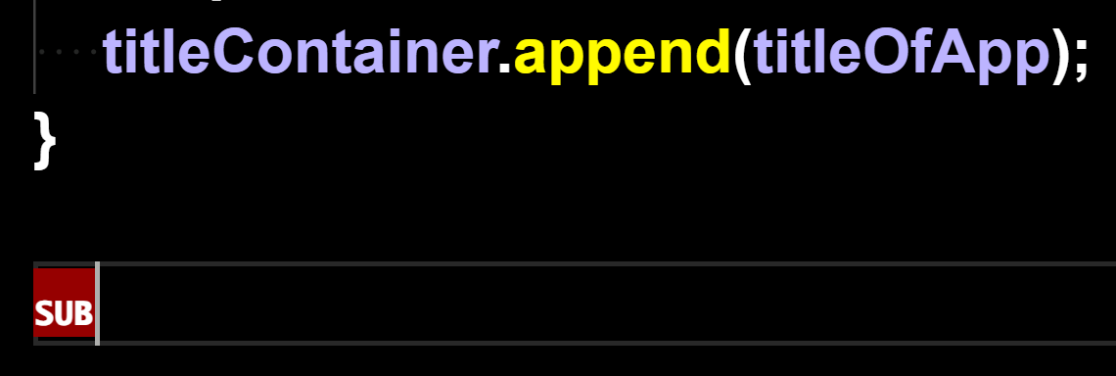
But, there is a junk character at the end of the main.js script that we have to delete. In VSCode the character might be called SUB
We remove this junk SUB character and the code will now run.
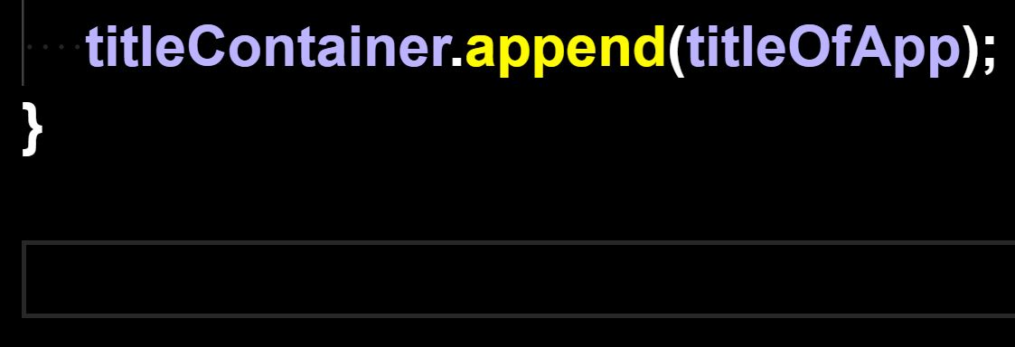
As we can see, the junk character is removed.

<!-- Now, in our html code, we can type -->
<script src = 'main.js'></script>

This makes it much easier to upload our js code to our website.
How to Combine
.js files
into one
main.js file
using
Command
Prompt

Version for when we have js scripts in subfolders in our js project folder, that we want to combine.
// HowToCombineJSFiles.js
TUTORIAL:
How to Combine all .js files in all folders that are in our js folder.

Getting things ready:
We should add two new lines at the end every script. This way they will combine nicely with a line break in between each script.

Step One: Open our js folder

Step Two: Type in the address bar of the js folder, cmd, press Enter

This opens our js folder in the command prompt

Step Three: Type the command shown below in the command prompt and then press Enter

for /r "%CD%" %i in (*.js) do type "%i" >> main.js

Now we have a newly created .js file named main.js that has all of our js files included into one file.

This makes it easy to upload our application and easy to find out how many lines of code our project is.

To use our main.js file, we include it in our html file code:
<script src = 'js/main.js'></script>
Happy Scripting :-)
How to Combine
.js files
into one
main.js file
using
a batch file

Version for when we have js scripts in subfolders in our js project folder, that we want to combine.
// HowToCombineJSFilesUsingBatFile.js

We can combine all of the .js files
that are located in our js folder
into one main.js file, using either:
The Command Prompt Method
or
The .bat File Method

The .bat file method is very easy.
We double click the bat file, which is located in our js folder, and it will make a main.js file, which includes all .js files in the js folder, including all .js files in all subdirectories of our js folder.

This is a very easy way to combine our .js files, because we can double click the .bat file anytime, and it will again generate the main.js file, which includes all .js files in the js folder, including all .js files in all subdirectories of our js folder. This makes uploading our application online much easier.

Happy Scripting :-)

:: Topalian_Combine_JS_Files.bat

:: This .bat File Combines All .js files in all folders of our project folder, into one main.js file.

:: To activate this .bat file, we double click the .bat file, while it is located in our js folder.

@echo off
:: set the output file name
set "output=main.js"

:: clear existing output file
type nul > "%output%"

:: loop through all JavaScript files in subdirectories
for /r %%i in (*.js) do (
:: append the content of each file to the output file
type "%%i" >> "%output%"
)

echo "JavaScript files combined into %output% successfully."

How to Combine
.js files
into one
main.js file
using
Node.js

This version will successfully combine a single folder of js files.
It also works to combine js files in all subdirectories.
// Topalian_Combine_JS_Files.js

let fs = require('fs');
let path = require('path');

function combineJSFiles(directory, scriptFilename)
{
let outputFilePath = path.join(directory, 'main.js');

let fileContents = [];

function traverseFolder(folder)
{
let files = fs.readdirSync(folder);

for (let i = 0; i < files.length; i++)
{
let file = files[i];

let filePath = path.join(folder, file);

let stats = fs.statSync(filePath);

if (stats.isDirectory())
{
traverseFolder(filePath);
}
else if (path.extname(filePath) === '.js')
{
let content = fs.readFileSync(filePath, 'utf8');
// check if file is not script file itself
if (filePath !== scriptFilename)
{
fileContents.push(content);
}
}
}
}

traverseFolder(directory);

fs.writeFileSync(outputFilePath, fileContents.join('\n'), 'utf8');

console.log(`Combined ${fileContents.length} .js files into ${outputFilePath}`);
}

// get current directory of script
let currentDirectory = process.cwd();

// get filename of script
let scriptFilename = __filename;

combineJSFiles(currentDirectory, scriptFilename);

How to Combine
.js files
into one
main.js file
using
Python

This version will successfully combine a single folder of js files.
It also works to combine js files in all subdirectories.
# Topalian_Combine_JS_Files.py

import os

def combineJSFiles(directory, scriptFileName):
outputFilePath = os.path.join(directory, 'main.js')
fileContents = []

def traverseFolder(folder):
for root, dirs, files in os.walk(folder):
for file in files:
filePath = os.path.join(root, file)
if filePath != scriptFileName and filePath.endswith('.js'):
with open(filePath, 'r', encoding='utf-8') as f:
fileContents.append(f.read())

traverseFolder(directory)

with open(outputFilePath, 'w', encoding='utf-8') as f:
f.write('\n'.join(fileContents))
print(f"Combined {len(fileContents)} .js files into {outputFilePath}")

# get current directory of script
currentDirectory = os.path.dirname(os.path.abspath(__file__))

# get filename of script
scriptFileName = os.path.abspath(__file__)

combineJSFiles(currentDirectory, scriptFileName)

What other file types can we combine?

We have combined .js files in this book, but we might choose to instead combine:

.py or .html or .txt

This is very useful for book making.

In each of the scripts shown in this book, we can manually change the parts where it says .js, with .py, if we wanted to, for instance, copy all .py files into one main.py file.

We can do the same thing for .html files, where we change the file type it will be combining to .html and it will combine all .html files into one main.html file.

We add two line breaks at the end of all files, so that there is space between files, when they are combined.

Remember too, that not all file types will combine, but the ones above will.

The original files are not changed. The content from the original files is only copied from.

True Artificial Intelligence System
Tautology
1111
Contra-
-diction
0000
XOR
0110
XNOR
1001
AND
0001
NAND
1110
OR
0111
NOR
1000
MI
1101
MNI
0010
LP
0011
LC
1100
RP
0101
RC
1010
CI
1011
CNI
0100
16-Gon
For More Tutorials:

GitHub.com/ChristopherTopalian
GitHub.com/ChristopherAndrewTopalian
Sites.google.com/view/CollegeOfScripting
CollegeOfScripting.weebly.com
CollegeOfScripting.wordpress.com
Youtube.com/ScriptingCollege
Twitter.com/CollegeOfScript
Rumble.com/user/CollegeOfScripting
Dedicated to God the Father
This book is created by the
College of Scripting Music & Science.
Always remember, that each time you write a script with a pencil and paper, it becomes imprinted so deeply in memory that the material and methods are learned extremely well.

When you Type the scripts, the same is true. The more you type and write out the scripts by keyboard or pencil and paper, the more you will learn programming!

Write and Type every example that you find.
Keep all of your scripts organized.
Every script that you create increases your programming abilities.
SEEING CODE, is one thing,
but WRITING CODE is another.
Write it, Type it, Speak it, See it, Dream it.
CollegeOfScripting.weebly.com

